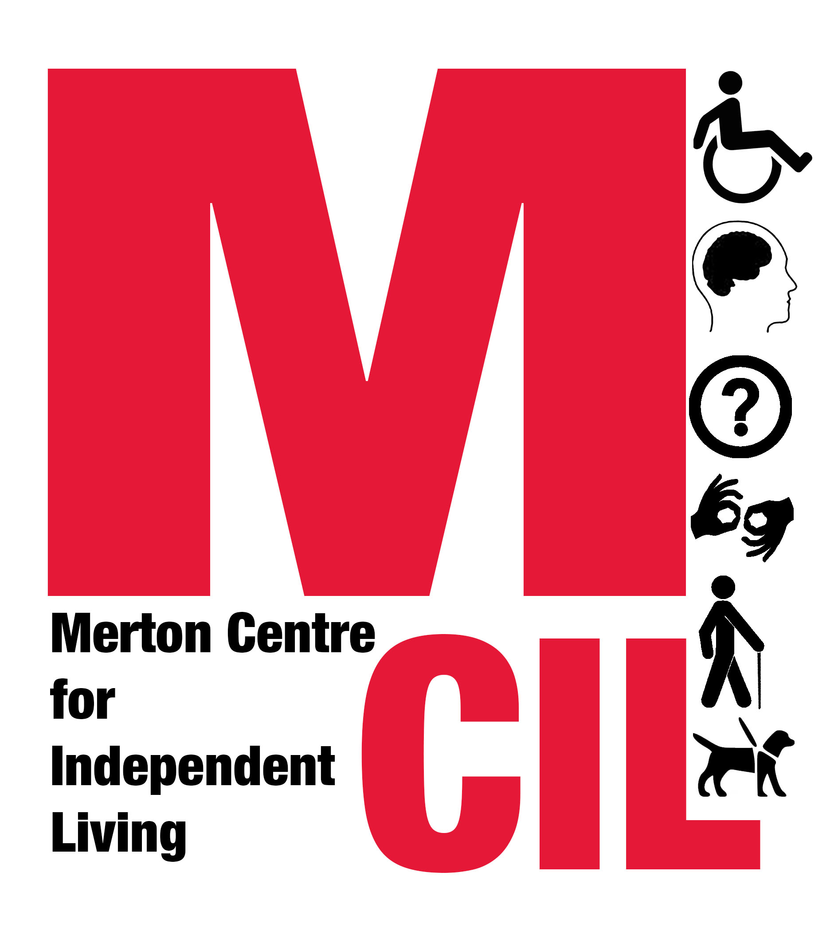
Job Description and Person Specification

Job title | Case Worker (Advice and Advocacy)
Reporting to  Hours | Service Manager  35 hours per week
Salary £25,000 - £29,000 pro-rata

Contract type Fixed-term until 31 March 2018 (with the possibility of extension subject to funding)

Overall Purpose of Role

Working in line with our values as an organisation, to provide advice and advocacy support to disabled people in Merton in order to enable them to live independently and have as much choice and control over their lives as possible.

About Merton CIL

Merton CIL is a user-led organisation promoting the inclusion, choice, and independence of disabled people in Merton. We were established to provide a voice for disabled people in the borough and to provide support to disabled people in all areas of their lives.

About the Advice and Advocacy service

Merton CIL set up our services because our members and other disabled people in Merton asked us to, and because there is a gap in provision in Merton.

We provide advice in people’s own homes, and support people to speak up at a range of formal meetings such as assessments and welfare benefit tribunals.

Experienced advisers and advocates have knowledge of a very broad range of subjects and at Merton CIL, while we encourage broad knowledge, we also ask employees to focus on key topics which are most in demand locally.

For this role, we are specifically looking for someone to provide Benefits and Money advice and casework. There will also be opportunities to provide housing, community care and health advice and advocacy.

Key Tasks and Responsibilities
- To support disabled people in Merton and to provide them with accurate advice, information and guidance in their own homes, enabling them to live more independently.
- To carry a caseload, providing support to disabled people on a person centred basis in order to enable them to have as much choice and control over their lives as possible.
- To carry out Benefits checks and calculations and provide support with form-filling, reviews and appeals.
- To support disabled people in a wide range of formal settings including, but not limited to, ESA and PIP medical assessments, and Social Security Tribunals.
- To support disabled people with money and budgeting advice, to apply for grants and to negotiate with third parties as required eg, DWP, HMRC, local authorities, utility companies and bailiffs.
- To identify social policy issues and undertake social policy work as required.
- To raise safeguarding concerns under the supervision of the Service Manager.
- Where appropriate, to refer people to other services in line with our policies, including other Merton CIL services.
- To keep accurate and detailed records of enquiries received and advice and/or support given.
- To be responsible for the implementation of monitoring, evaluation and quality assurance procedures.
- To research and to keep informed of new legislation and changes to existing law and policy on issues affecting disabled people.
- To keep up to date on what is offered by other agencies and promote collaborative working relationships with associated agencies within the Borough.
- To prepare for, attend and contribute to support and supervision sessions.
- To prioritise and manage cases in line with quality standards.
- To carry out peer case reviews.
- To ensure appropriate public promotion of the service and to contribute to the design and updating of publicity materials for the service.
- To carry out the duties of the post within an equal opportunities framework and adhere to all Merton CILs policies and guidelines including our Values and Independence Charter.
- To undertake such duties as from time to time may reasonably be required.
- This job description reflects the requirements of the post at the time of writing. The needs and circumstances may change over time and therefore the Job Description may need to be reviewed in the light of any such changes which may occur.

Person Specification
Essential
- Two or more years’ experience of giving Benefits and Money Advice to the public on a one-to-one basis.
- Ability to research, analyse and interpret complex rules and information.

Excellent written and oral communication skills, including the ability to explain and summarise complex rules and information in simple terms.
- Effective advocacy and negotiating skills.
- Ability to enable people to resolve their problems.
- Ability to plan and prioritise own work and meet deadlines.
- Ability to be flexible and responsive to change.
- Willingness to learn and develop.
- Ability to work effectively as a member of a team.
- Ability to handle with discretion information which may be confidential or sensitive.
- Strong IT skills (including Word, Excel, Outlook) and ability to use electronic monitoring to keep records of casework.
- Able to demonstrate an empathy for the issues and barriers faced by disabled people and an understanding of the policy issues affecting their lives.
- Must have a strong personal commitment to supporting people across the spectrum of disability or health issues, and supporting people from a variety of ethnic and social groups.

Desirable
- Experience of providing advice and/or advocacy in the following areas
  - Housing
  - Community Care
  - Health
- Lived experience of disability
- Experience of working in outreach locations and/or providing a home-visiting service
- Experience of a user controlled and led organisation
- An understanding of the Merton voluntary sector and local authority structures
- An understanding and knowledge of the Social Model of Disability, the Independent Living Movement and a commitment to the disability rights movement
We are an equal opportunities employer and we will interview and consider on their abilities disabled applicants who meet the essential criteria for a job vacancy at Merton CIL, if they declare their disability at application.
If you require additional support completing this application due to an access need, please get in touch on 0203 397 3119
Please apply with:
- A completed application form
- A completed monitoring form
to info@mertoncil.org.uk
Closing date for applications: Monday 9 October (11.59pm)
Planned interview date: w/c Monday 16 October and/or Monday 23 October


This role is funded by Big Lottery Fund’s Reaching Communities Programme and London Borough of Merton
Charity Number 1152825

