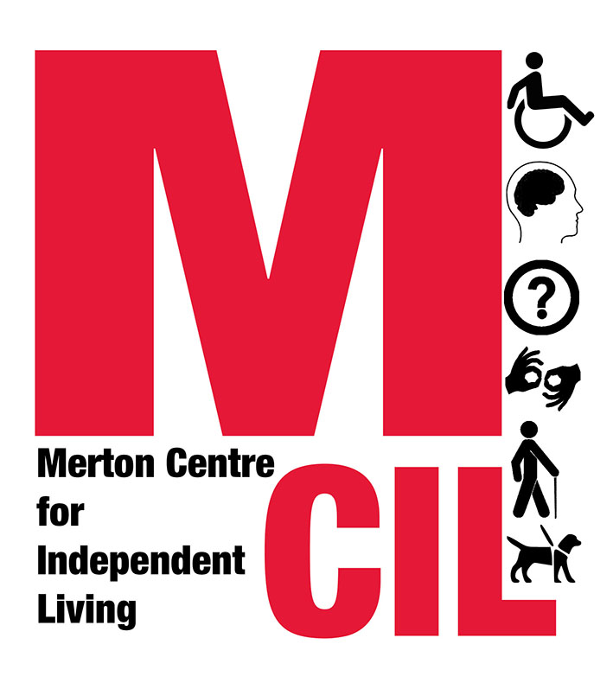
Job Description and Person Specification
CEO

Job Title CEO
Reporting to Chair of the Board of Trustees
Hours 35 hours per week
Responsible for Staff team
Salary £40,000 - £44,000
Contract type Permanent

Overall Purpose of Role:

The CEO provides leadership, strategic development, builds relationships with key organisations and stakeholders, and delivers accountability to funders, as well as day-to-day operational management and oversight of the staff team.

About Merton CIL

Merton CIL is a user-led organisation promoting the inclusion, choice, and independence of Deaf and Disabled People in Merton. We were established to provide a voice for Deaf and Disabled People in the borough and to provide support to Deaf and Disabled People in all areas of their lives.

You can find out more about Merton CIL by watching this short film: https://www.youtube.com/watch?v=ecTQIfU4Doo

Key Tasks and Responsibilities

Strategic Development
- To work with the Board, and consult with members, local Deaf and Disabled people and staff, as appropriate, in the formulation, implementation and review of long term strategies for the development of Merton CIL in line with our values.
- With the Board, to develop appropriate Business Plans based on our Strategy
- With the senior team, develop services based on identified need and in line with our strategy

Support the Board of Trustees
- To support the role of the Board as the governing body of Merton CIL, by ensuring that Board meetings have access to appropriate and accurate information, and that business is conducted in accordance with the Memorandum and Articles of Association, and any other legal or regulatory requirements.
- With the Chair, to develop an effective board with a range of appropriate skills and experiences
- To keep abreast of developments in the voluntary/community/not-for-profit sectors, Deaf and Disabled People’s community and other areas to highlight the implications for the organisation.

Staff management and Personnel
- To take appropriate decisions in the day-to-day running of the organisation as delegated by the Board.
- To directly line manage senior staff, and ensure that management of the frontline team is appropriately delegated
- To work with the Board and senior team to identify and develop appropriate internal policies, procedures and strategies.
- To ensure that the organisation complies with all relevant employment legislation; and that the organisation is supported by appropriate personnel policies and procedures to support staff in carrying out the duties of their posts.
- To ensure that policies and procedures are in place to make sure that any volunteers are appropriately supported, supervised and rewarded.

Monitoring and Evaluation
- To co-ordinate and monitor progress towards work plans and targets
- To co-ordinate evaluation and monitoring procedures, including the collation of reports for funders and the Board.
- To monitor service delivery in line with Quality Assurance procedures
- To support the M&E Steering group and manage external evaluation

Financial, Funding and Fundraising Responsibilities
- To take responsibility for day-to-day financial management of the organisation, working in conjunction with the Treasurer and Office Manager to produce the annual budget, quarterly management accounts, cash flow statements and forecasts for the Board, as well as annual accounts
- To monitor income and expenditure to ensure that the organisation stays within the budget set and remains financially viable.
- To develop and implement a fundraising strategy in line with our strategic plan
- To apply for funding in line with current strategic objectives and to seek new sources of income, including unrestricted income.

External Relations
- To promote and publicise the work, aims and purpose of Merton CIL
- To identify and engage with key allies and potential partnership agencies for Merton CIL’s work.
- To co-ordinate the production of publicity materials, information and resources and the web site produced by Merton CIL, including the Annual Review.
- To contribute to the production of regular Stakeholders email news and policy briefings.
- To respond to national and local government consultations on behalf of the organisations and our members and stakeholders.
- To ensure Deaf and Disabled people are represented on key decision-making forums within the Borough

General duties and tasks
- To carry out the duties of the post within an equal opportunities framework and adhere to all Merton CIL’s policies and guidelines including our Values and Independence Charter.
- To undertake such duties as from time to time may reasonably be required.
- This job description reflects the requirements of the post at the time of writing. The needs and circumstances may change over time and therefore the Job Description may need to be reviewed in the light of any such changes which may occur.

Person Specification

Essential Experience
- Proven leadership role within the public, private or voluntary sector and/or a Deaf and Disabled person’s organisation.
- Proven experience of supporting and developing a board of trustees
- Track record of successfully recruiting, developing and managing people
- Significant experience developing, managing, monitoring and evaluating services
- A proven track record of securing / generating funding
- Experience developing and managing budgets and financial reporting in collaboration with the Treasurer
- Demonstrable experience managing, promoting and engaging with stakeholders and partners

Essential Skills and capabilities
- An understanding and knowledge of the Social Model of disability, the Independent Living Movement and a commitment to the disability rights movement and the implications of these for management and organisational development.
- Able to demonstrate an empathy for the issues and barriers faced by disabled people, their needs and concerns, and an understanding of the policy issues affecting our lives
- A strategic thinker with evidence of successfully using their skills to transform strategic vision into reality.
- Ability to negotiate, influence and effect change and to develop working relationships with people from a wide variety of backgrounds.
- Excellent communication and presentational skills, with the ability to communicate successfully at all levels to a variety of audiences, taking into account the communication and access needs of Deaf and Disabled people.
- Demonstratable organisational skills, including the ability to prioritise competing demands and to work without close supervision.
- Ability to work collaboratively and to work co-operatively with the Board and other staff members.
- Ability to be flexible and responsive to change.
- Must have a strong personal commitment to supporting people across the spectrum of disability and/or health issues, and supporting people from a variety of ethnic and social groups
- Commitment to and of understanding of equal opportunities, diversity and human rights and their implications for management and organisational development.

Desirable criteria

- Lived experience of disability and/or deep understanding of disability
- Experience of a user controlled and led organisation
- An understanding of the Merton voluntary sector and local authority structures

We are an equal opportunities employer and we will interview and consider on their abilities Deaf or Disabled applicants who meet the essential criteria for a job vacancy at Merton CIL, if they declare their disability at application.
If you require additional support completing this application due to an access need, please get in touch on 0203 397 3119
Please apply with:
- A completed application form
- A completed monitoring form
to info@mertoncil.org.uk

Deadline for applications: 9am Tuesday 7th May 2019
Interviews planned w/c: w/c 13th May 2019


This role is funded by a range of funders including Big Lottery Fund’s Reaching Communities Programme, as well as Trust for London, MOPAC / London Communities Foundation and Henry Smith Charity.

Merton CIL Charity Number 1152825

