~~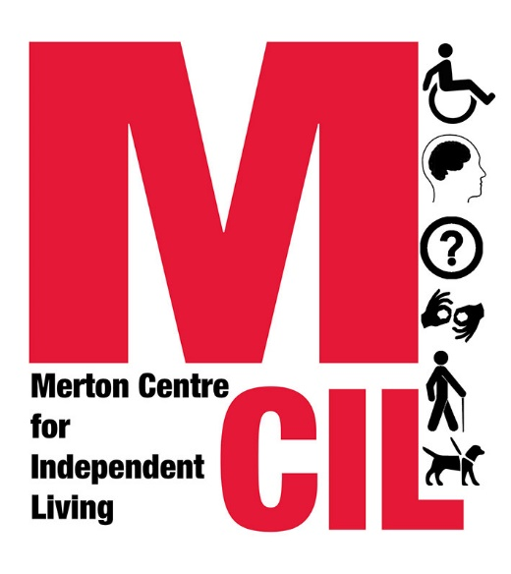~~**Service User Complaints Procedure**

**Version 10 2024-25**

Every year Merton Centre for Independent Living supports several hundred Deaf and Disabled people in Merton. We are committed to delivering the highest level of service for all our users.

Lots of people are satisfied with the services we offer, and we are always happy to hear about what went well for people. But sometimes people tell us they are not happy and would like to see improvements.

Perhaps they had to wait to speak with us, only to find out that there is very little we can do for them. Perhaps they felt that they were not treated with respect or courtesy. Perhaps our support did not achieve the outcome they wanted.

Unfortunately, these things can happen. We know we are not perfect even though we try very hard to get things right. That is why we have a complaints procedure. Sometimes we can put things right. Sometimes all we can do is say sorry. But we will always try to learn from what went wrong and do better next time.

We will handle what you tell us confidentially, seriously and quickly.

**What is the complaints procedure?**

**Stage 1: Tell us what you think**

There are lots of ways to comment on our services. We phone a random selection of people on a regular basis, so if we call you, please provide feedback. We also carry out an annual survey and we have a comments box in the office. However, if you are particularly concerned, worried, or unhappy with any aspect of our service the first person to speak to is the worker delivering the service. The worker will talk to you about the issue, make a note of your concern and try to sort it out straight away. We call this stage raising a concern. We still take everything you tell us seriously, and we aim to sort things out quickly at this stage.

If you are not happy with the response at this stage, or the plan of action did not work, or you think your concern is too serious to deal with this way, you can go to the next stage.

**Stage 2: Making a complaint**

You can make a complaint by telephoning 020 3397 3119 and asking to speak with the Advice Quality Manager or another member of the Senior Management Team, by emailing [info@mertoncil.org.uk](mailto:info@mertoncil.org.uk) or by using the form at the end of this document. If you need to use SMS because you are deaf, please use 07796 712502. Some people might need support to make a complaint. We suggest using an organisation like your local Citizens Advice to support you.

When you make a complaint, Stage 2 will usually be handled by the Advice Quality Manager or the Policy & Campaigns Manager.

Where the complaint is about the Service Manager or the Policy & Campaigns Manager, one of the two Joint CEOS will handle Stage 2.

Where the complaint is about one of the two Joint CEOs, the other Joint CEO will handle Stage 2.

Sometimes we might ask you to go through Stage 1 if you have not already done so, as we believe this is the most successful way of addressing issues in the first instance.

If we uphold your complaint, you will get an apology and, where appropriate, you will be given details of any action that we are taking to put things right. This might mean we look at our procedures or give our staff some training.

We aim to provide a Stage 2 response within one calendar month of the start of Stage 2.

**Stage 3. Appeal**

If you are not satisfied with the outcome at Stage 2, you can ask for a further review. Stage 3 will usually be carried out by one of the Joint CEOs.

Where the complaint is about the Advice Quality Manager or Policy & Campaigns Manager, the Joint CEO who did not handle Stage 2 will handle Stage 3.

Where the complaint is about one of the two Joint CEOs, Stage 3 will be handled by a Trustee or an external person appointed by the Board of Trustees.

The person handling Stage 3 will always be different to the person handling Stage 2.

The person reviewing the complaint at this stage will look at the original complaint and at how it was addressed and will ask you to explain why you are appealing.

We aim to respond in full to your complaint at Stage 3 within six weeks of the start of Stage 3. However, if the issue is complicated and more time is needed, the reasons for any delay will be explained and you will be kept informed of progress.

There are no further complaint stages after this and any decision at Stage 3 will be final.

**What will not be investigated through the Complaints Procedure**

* Where the matter is being or has been dealt with through legal action or an insurance or liability claim.
* Where the cause for complaint is more than 6 months old but is only reported now, unless there is good reason for delay.
* Where the complaint is an attempt to reopen a previously concluded complaint where we have already given our final decision.

Where the contact from the service user is unreasonably persistent or vexatious, we may choose to close the complaint at any stage with a final letter outlining our actions and response to the issues originally raised by the service user.

|  |  |
| --- | --- |
| Date this policy came into effect  01/10/2014.  Date refreshed/approved with new logo and structure: 26/01/2016.  31/03/2016 changed review date.  26/10/2017 refreshed with input from M&E Group.  09/11/2018 Updated to include what to do when complaint is about CEO.  26/04/2019 Response time at Stages 2 and 3 clarified.  17/02/2021 Reviewed by Senior Caseworker and Service Manager (changes made to reflect new management structure. No other changes).  25/01/2022 Reviewed by Service Manager. Changes made to reflect new Joint CEO management structure. This is now Complaints only, rather than Compliments, Comments, Concerns and Complaints. Separate P & P to be considered for Compliments.  14/02/2023 Reviewed by Service Manager. Minor amendments to wording. No changes to meaning, process or substance.  16/04/2024. Reviewed by Advice Quality Manager. Job titles amended, otherwise no changes. | Date approved by Governing Body  16th Sept 2014 |
| Next Review Date: March 2025 |  |
| Name or position of person responsible for this policy | Joint CEOs |

~~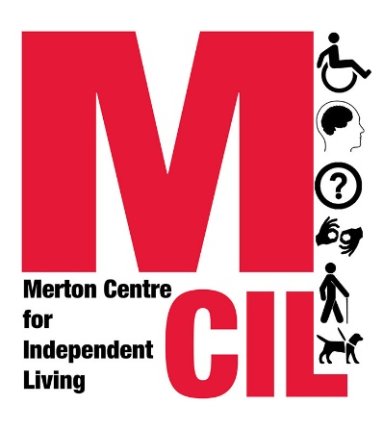~~**Complaints Form**

You do not have to give your name and address but we will not be able to contact you without your details.

Name: …………………………………………………………………….

Address: ………………………………………………………………….

……………………………………………………………………………..

……………………………………………………………………………..

……………………………………………………………………………..

Phone number: …………………………Email ………………………...

Please return form to:

Advice Quality Manager

Merton CIL

Vestry Hall

336 London Road

Mitcham

Surrey CR4 3UD

Or [info@mertoncil.org.uk](mailto:info@mertoncil.org.uk)

On the form below please provide information about the service or event you are complaining about. Please provide as much information as possible to help us consider all the facts and respond quickly.

Signing this document means that you understand that a Merton CIL Senior Manager or Trustee will access your case file, contact you about the complaint and keep a log of action undertaken to try to resolve your complaint.

…………………………………………………………………………………………..

…………………………………………………………………………………………..

…………………………………………………………………………………………..

…………………………………………………………………………………………..

…………………………………………………………………………………………..

…………………………………………………………………………………………..

…………………………………………………………………………………………..

…………………………………………………………………………………………..

………………………………………………………………………………………….

…………………………………………………………………………………………..

…………………………………………………………………………………………..

…………………………………………………………………………………………..

…………………………………………………………………………………………..

Your signature: ………………………………..Date:………………………..

Please print your name: ……………………………………………………