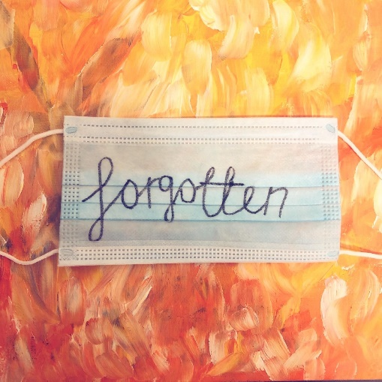

Coronavirus, Lockdown, Shielding and Beyond.

The experiences of Deaf and Disabled people in Merton

Published: September 2021

Contents Page

Acknowledgments…………………………………………………………………………………………….2
Foreword…………………………………………………………………………………………………………2
Executive Summary………………………………………………………………………………………….3
Introduction……………………………………………………………………………………………………5
Background……………………………………………………………………………………………………..8
Wellbeing and Lockdown………………………………………………………………………………….11
Staying Connected…………………………………………………………………………………………..16
Loneliness and Isolation……………………………………………………………………………………18
Other Issues…………………………………………………………………………………………………….21
The Merton CIL Experience……………………………………………………………………………….27
Conclusions and The Future………………………………………………………………………………31

Report by Michael Turner, Policy and Strategy Manager, Merton Centre for Independent Living.
Email: michael@mertoncil.org.uk
www.mertoncil.org.uk
@MertonCIL
Registered Charity Number: 1152825 - Company Number: 7645926

Acknowledgments

Merton CIL wishes to acknowledge the support of the Wimbledon Foundation via London Community Response for providing financial support to complete this piece of research. We also want to thank the local Deaf and Disabled people that shared their time and lived experience that fed into this report and will help to ensure that Deaf and Disabled people in Merton emerge from the pandemic maintaining independence and inclusion.

Foreword

Merton CIL is pleased to publish this account of the experiences of Deaf and Disabled people in Merton during the coronavirus pandemic during 2020 and the first part of 2021.
These have obviously been very difficult times for everyone but there is a growing body of evidence that Deaf and Disabled people have been particularly badly affected by the virus itself and the steps that the authorities have taken to deal with the situation. Changes and restrictions were imposed which had particular impacts on Deaf and Disabled people, often with little or no consultation.
The report gives a picture of what happened for Deaf and Disabled people in Merton, with the accounts given to Merton CIL through individual interviews, a focus group, a small survey and a review of the work of Merton CIL throughout this time. We hope it will help to ensure that the voices of Deaf and Disabled people are heard in the plans and changes being made to develop the borough as we come out of the crisis.
We would like to thank the people who took the time to speak to us and gives thanks on behalf of the board of trustees to all of Merton CIL’s staff for their work for Deaf and Disabled people at such a difficult time.
We are also grateful for the support of the Wimbledon Foundation via London Community Response for funding this project.
Gina Vetesse, Vice Chair of Merton CIL

Executive Summary

Merton CIL has produced this report to capture the experiences of Deaf and Disabled people of the coronavirus pandemic from 2020 – mid 2021. The aim is to look at what lessons can be learned from the crisis to improve the lives of Deaf and Disabled people in the future.
Nationally, 60% of people who died from Covid 19 were Disabled people and a number of enquires have shown that the crisis had a particular impact on Deaf and Disabled people. These ranged from being discriminated against by health care services to difficulties getting essential food and shopping and difficulties around facemasks.

Key findings

Wellbeing and lockdown
People had mixed experiences of the lockdowns, but it had significant impacts on people’s wellbeing, particularly those with experience of mental health issues.
While some were happy to see lockdown rules ending, others had anxieties about their end and their concerns are likely to continue for some time to come.

Loneliness and isolation
Deaf and Disabled people experienced loneliness and isolation along with the general population. Some felt they found the situation more difficult to deal with than other because of their disability, particularly where they had had experience of mental health issues.
Others felt they were able to deal with the situation better because of their experiences as Disabled people, with some saying the lockdowns mean non-Disabled people were experiencing the lives that Disabled people live all the time.
Technology and the internet helped many people to stay connected with friends and family, although there was also evidence of the ‘digital divide’ and lack of access to equipment and the skills to use it.
Finances
Most people did not experience financial problems, though this may be because a large proportion of Merton CIL’s members and service users received benefits before the pandemic.
Accessing healthcare and services
A number of people experienced difficulties accessing health services, particularly mental health services.
There were mixed about accessing health services online and/or by telephone, some people liked it, but some had delayed or experienced delays getting treatment.

Recommendations
- Put equality for Deaf and Disabled people and all disadvantaged groups at the heart of recovery and development programmes coming out of the pandemic, including recognition of issues around intersectionality.
- Put awareness and understanding of mental health at the core of services and for Deaf and Disabled people along with work to promote awareness of these issues and their impact.
- Work to develop awareness and understanding of the situation of people with hidden impairments.
- Maintain a combined offer of in-person, telephone and online services and participation.
- Services and support need to be available for Deaf and Disabled people who need to develop their digital skills.
- Access will always be a concern for Deaf and Disabled people and it is essential there is full consultation about any changes to the built environment/streetscape, especially when changes are being made quickly as happened in the pandemic.
We believe these recommendations are relevant to the Council, health, voluntary sector services and the private sector. This includes Merton CIL itself which will be starting a strategic planning process in late 2021 and will include consideration of these points.

Introduction

1.1 Aims of this report
It is now well documented that the coronavirus pandemic in the UK has had a greater impact on Deaf and Disabled people than non-Disabled and hearing people. We give further details of this in the Background section.
This report aims to document the experiences of Deaf and Disabled people in Merton through the crisis from early 2020 through to mid-2021, along with how Merton Centre for Independent Living has worked as Deaf and Disabled People’s Organisations and continued to support people through the crisis.
The aim is to look at what lessons can be learned from an 18-month period unlike any that we have experienced as a country, as a borough and as individuals and families in our communities and neighbourhoods, and how this can improve the lives of Deaf and Disabled people in the future.
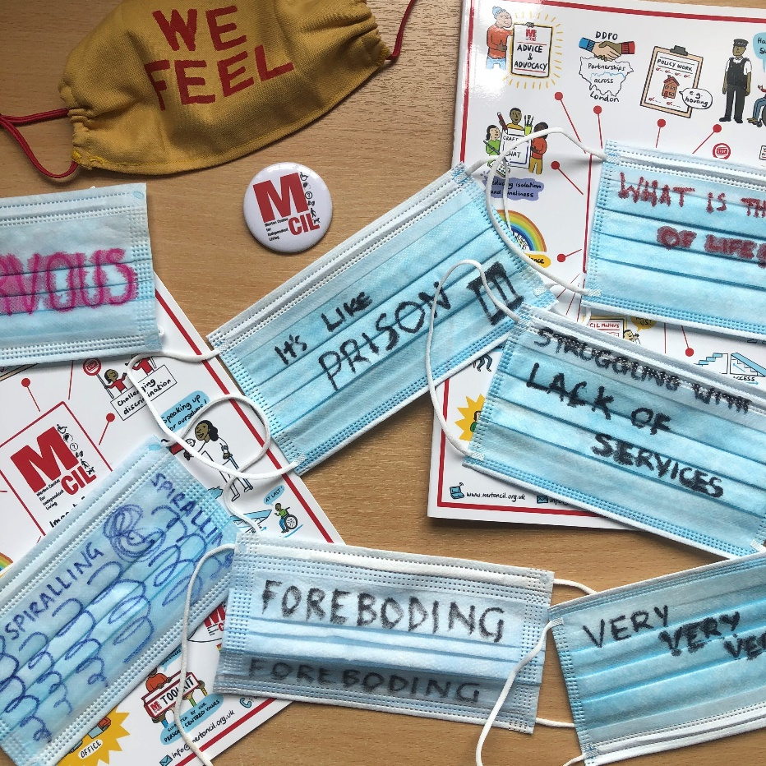
There can be no doubt that this has been a terrible time for many people. But if there is anything positive that can be taken from what has happened it is that there are lessons we can learn about how we work together as a borough and in our communities and neighbourhoods with and for Deaf and Disabled people.

How we researched this report
Research for this report was targeted and we spoke with a small percentage of our membership who have a range of disabilities and health conditions. For this research we conducted:
- A brief literature review
- A desktop audit of local resources
- A focus groups with 11 local Deaf and Disabled people
- A survey with local Deaf and Disabled people
- An in-depth interviews with 8 Deaf and Disabled people
People came forward in a short online survey that we carried out in June and July 2020 which 10 people completed. We then held a focus group discussion with 11 people and individual interviews with a further 8 people. This included women and men, people from BAME communities, people across a wide age range from their 20s up people in their 80s, and people with a range of impairments including people with physical impairments, Deaf people, people with learning difficulties and mental health service users/survivors. There was some overlap between the people who completed the survey and took part in the focus group and interviews.
During the first lockdown Merton CIL recognised that Deaf and Disabled people may have been presented with a number of issues. We started a programme of calling Deaf and Disabled members to check in whether there was anything we could help them with and provide an opportunity to talk to someone. Staff in the advice and advocacy service made contact with 73 people from Merton CIL’s membership. Contact with these members included short check in, and longer calls giving short sessions of support, and a number of calls for some people who needed further support. These calls were not intended to be part of this research project so it would be inappropriate to refer to any details of individual calls in this report. However, we have referenced the general themes that came through from the calls overall. Nine of the members contacted were people who took part in the project through interviews or the focus group, so to avoid duplication we have not included them in the numbers where this report refers to the number calls to members as 64.
The report also has a section on the work of Merton CIL during the pandemic and the views of 5 of Merton CIL’s 9 staff on their experiences working through this time. While the bulk of the report was researched and written by Merton CIL’s Policy and Strategy Manager, an independent consultant carried out the interviews for this part of the project to give a degree of independence to this of the process.

1.3 About Merton CIL
Merton CIL is a pan-disability user-led Deaf and Disabled People’s Organisation that has been supporting Deaf and Disabled People in the borough since 2008. We support people across a wide range impairment including physical and sensory impairments, long term health conditions, learning difficulties and neurodiversity. Many of our service users have more than one impairment, and many are also carers and/or parents.
We are run and controlled by and for Disabled people and work to address marginalisation and make a real difference in Merton and the wider community. We want a society where Disabled people achieve full equality and inclusion. Deaf and Disabled People don’t have to be members to use our services but we do have an ever-growing membership who shape our direction and focus as an organisation.
We work within the social model of disability and an independence charter, co-designed with Disabled people to ensure we can influence key issues affecting our lives in a variety of ways.
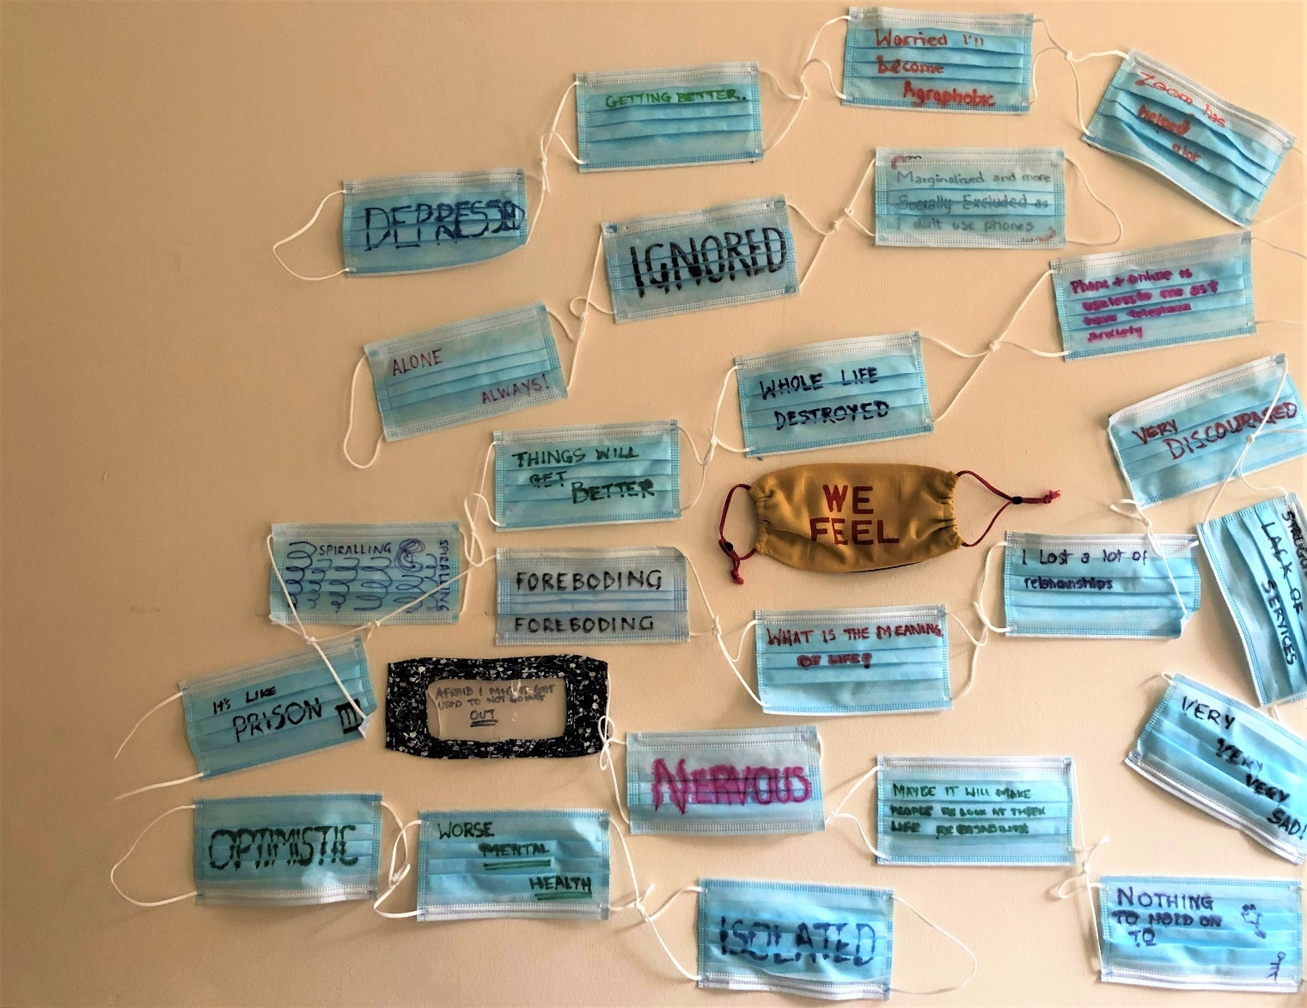

2. Background

2.1 Coronavirus statistics for Merton
There were 481 deaths from Covid 19 in Merton residents between January 2020 and April 2021. Of these, 373 deaths occurred in hospitals, 48 in care homes, 50 at home and 1 elsewhere.
While there are many statistics relating to death and infection rates, it has proved difficult to identify comparative figures to compare the figures for Merton and other London boroughs. It appears that the most recent figures that allow such a comparison over a time greater than a few days or weeks are from the Office for National Statistics for 1 March – 31 July 2020. For this period, the number of deaths per 100,000 in Merton was 141.2. This was broadly in line with the rates across the London boroughs, although it was higher than the neighbouring boroughs of Kingston, Sutton and Wandsworth.

2.2 Coronavirus and Deaf and Disabled people
It became evident early in the pandemic that Deaf and Disabled people were experiencing particular impacts from the situation.
This starts with the stark figures from the Office of National Statistics that between January and November 2020 60% of deaths from Covid 19 were Disabled people. It said no one factor explained this figure and that people’s financial situation, housing and where they lived all had an impact as well as pre-existing medical conditions.
Beyond this, there have been a number of investigations into the impact of the pandemic on Disabled people. The House of Commons Women and Equalities Committee held an enquiry on and published a report on the impact of coronavirus on Disabled people’s access to services and support. It identified a range of issues including access to treatment for Disabled people with Covid 19 and the use of do not resuscitate orders without consent, difficulties accessing food, the position of care homes and other social care services, the communication barriers caused by facemasks, the lack of BSL interpretation for television addresses by the Prime Minister and press conferences, and the lack of engagement with Deaf and Disabled people during the crisis. The report also raised concerns about the Coronavirus Act’s provision which allowed councils to reduce some of their duties under the Care Act, which was also the focus of national campaigning by Deaf and Disabled people’s organisations. Most councils, including Merton, did not need to take this action, but the potential for this to happen caused concern and anxiety. This part of the Coronavirus Act has now been suspended.
It made a range of recommendations for the government to act on in the course of the pandemic, most of which have been met as the situation improved during 2021. The committee also recommended that the government should hold a specific independent enquiry on the impact of coronavirus on Disabled people once the crisis is over.
Among many other reports, Inclusion London surveyed Deaf and Disabled people’s experiences in the summer of 2020 with a follow up in early 2021. Its reports pointed to Deaf and Disabled people experiencing a greater impact on mental health, difficulties with social care, food poverty and problems getting food, increased levels of disability hate crime. The follow-up report found that Deaf and Disabled people were still experiencing difficulties accessing health services and financial difficulties. A new factor at this point was new access barriers being created for Disabled people by changes to the streetscape (roads and pavements) to support social distancing and address environmental concerns that were introduced during and following the lockdowns.
The Sisters of Frida has also looked at the way these issues have impacted Disabled women. It describes how the pandemic has had a greater impact on Disabled women because of the intersectionality of inequalities, particularly those around financial inequality.
Looking at the future, the long-term impact on many people who have had Covid 19 known as long Covid looks likely to lead to a significant rise in the number of Disabled people. Disability Rights UK see this as a new form of hidden disability and legal opinion suggests that someone with long Covid for over 12 months will meet the definition of a disability under the Equality Act.
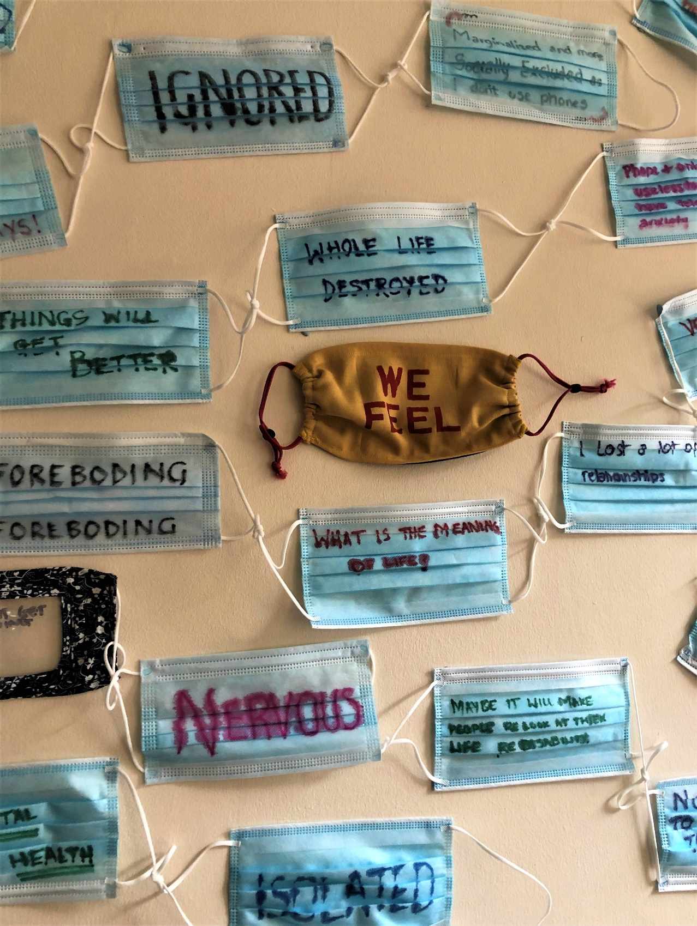

3. Wellbeing and lockdown

3.1 Wellbeing
We asked all the Merton CIL members and service users that we spoke to and/or responded to the online survey for this project to give a rating for their wellbeing and how this changed over the time of the pandemic. Many were familiar with the concept of rating wellbeing, and we were clear to everyone that it involved thinking about all aspects of their lives, including health, housing/and where you live, what you do, your family, friends and social contacts.
They ranged from very low, with two interviewees saying just 1 and another putting it around 2 or 3, with comments including:
‘I feel nervous, I don't go out for anything apart from work.’
‘I feel depressed and sad – I was already ill when this started.’
‘I feel very, very, very, sad.’
‘I've not lost hope but feel I have nothing to hold on to at the moment.’

Others clustered around the middle of the range, although noted wellbeing changed from day to day. Comments included:
‘I'm trying to be optimistic, but health is markedly worse, including mental health.’
‘It’s mixed. Some days I feel optimistic and that there is something I do in spite of all the restrictions. Some days I feel very depressed and isolated. There were a lot of things I was doing to help with my disabilities and my mental health that I can’t do now, I can’t meet with people. It gets really difficult for me to function on those days.’
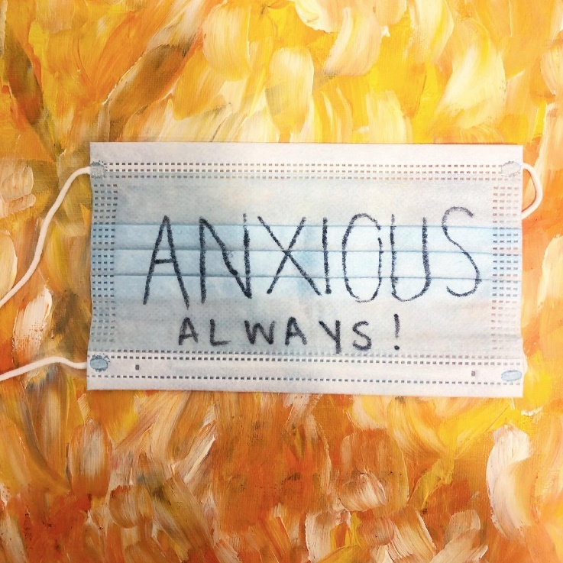
The highest ratings were three interviewees who put their wellbeing at 7 or 8.
The call round to members appears to have shown a similar picture. While we did not ask people to consider their wellbeing, 23 of the 64 people we spoke to said they were not experiencing any particular problems. Eight reported having difficulties with their mental health and this is likely to indicate that their wellbeing was low.

3.2 Changes over 2020 and 2021
Several of the people interviewed reported their wellbeing as much lower during the 2021 lockdown compared with the first in early 2020. The length of time that the lockdowns had gone was clearly having an impact, along with-it taking place in winter rather than spring and summer. People commented:
‘The shut down in December pushed me back quite a lot. It pushed me back into depression.’
‘What is the meaning of life right now? You wake up, go on the computer all day, then go to bed just to do the same thing again the next day.’
‘At beginning my wellbeing got worse but now it’s getting better.’
As has been noted in wider research, people with existing mental health problems have found the pandemic particularly difficult. One person told Merton CIL how they had been recovering from mental health issues at the start of the crisis and just getting back to seeing family and friends, along with doing things like going to the library and travelling by tube.

3.3 Lockdown
The experience of lockdown for Deaf and Disabled people in Merton was probably not dissimilar to the experience of the general population. Many of the people we spoke to had had to shield and had not been out at all during the lockdowns and extended shielding periods. People who had been out talked about just going shopping and being outside for short times.
‘I just got used to not going out, which is sad. I'm afraid I might get too used to it and not do anything.’
Going out, even for usually everyday activities, became a treat for many people:
‘I looked forward to my weekly hospital appointment.’
People described how they missed activities such as swimming but most developed new things like reading, going for walks and puzzles.
Friends and family became especially important to people, but this raised some concern about becoming a burden on others:
‘I didn’t want to burn my friends out. I'm really struggling with the lack of services and my family is falling apart.’
The closure of facilities and services for Deaf and Disabled people had a major impact. Not being able to go to day centres and recovery cafes left without much of their support or to pursue interests and activities including voluntary work.
People were able to highlight some positives from being at home much more than usual:
‘I have a long time to relax in the bath’.
Some felt they were better placed to deal with the lockdowns and shielding because of their experience as Disabled people. One person in the focus group noted:
‘I’ve got all that I need here, as long as I can do sudoku and crosswords I'm OK. I suppose because I was disabled from when I was one year old, and I've had to live with it all my life it’s not been as hard as it’s been for some people. I was shut away in a home until I was 16-years-old, so that gives you a different outlook on life and you’re able to cope better.’
This led another to comment:
‘Maybe this will teach non-disabled people what it’s like to live with a disability.’
Others were clear about the hugely negative impact the lockdowns had on them:
‘I really struggled with lockdown. I wanted to go out, I was stressed staying in, working from home and home tutoring.’
‘My whole life has been destroyed by this. Life was going well and now I feel I'm not doing anything. I'm annoyed.’
This person went on to say how their grandmother had died an illness unconnected with coronavirus, their family has lost lots of money and they were facing losing their job. They had been at university remotely during the lockdown and even this had been made more difficult after a cyber-attack on the university.
People did note that as the lockdowns progressed, things did seem to become easier. At the time when Merton CIL produced this report during the third lockdown, people reported feeling much easier about the situation:
‘When it was the first lockdown, I would just go out to shop once a week and be really anxious, I just wanted to get home as soon as possible. This time around it seems a bit better, I feel more comfortable. I'm not stressing like before.’

3.4 Easing lockdown
Some members expressed growing optimism about the improving situation in spring of 2021.
‘I'm looking forward to doing everything in person.’
‘Things will get better now.’
‘I'm looking forward to being able to go out a bit more, but I think I'm lagging behind how everyone else is feeling about it – I'm not ready to go out to a café tomorrow.’
However, some thought it might be difficult to get back to normal, with comments such as:
‘I'm not very optimistic, very discouraged. I still have a little bit of hope but being on your own in these circumstances has not been easy and I’m not ready to get back to normal… It’s going to be difficult to trust people and take risks’
‘I'm worried I’ll become agoraphobic.’
It appears that the pandemic and lockdown will continue to have an impact for some people beyond any official end date for restrictions.

4. Staying connected

Many of the people who responded to the project were very confident with technology and had been using it for communication and contact before the pandemic. This clearly helped them to deal with the lockdowns:
‘Having everyone on Zoom has been so good for me. I can go to events I couldn't go to before.
‘Zoom has helped a lot.’
‘I mostly used WhatsApp video.’
One person described how their friends had sent them voice notes on WhatsApp as an interesting and different way of staying in touch:
‘The voice notes helped a lot because I could just play them and pause them. It means I have someone else’s voice in the room but I don't have to expend as much energy as I do on video calls. It’s like getting a letter or email in audio and sometimes even better. Sometimes my friend will record a sound like the sound of her cycling through London, or the sound of a bird song. It’s like little windows into the world.’
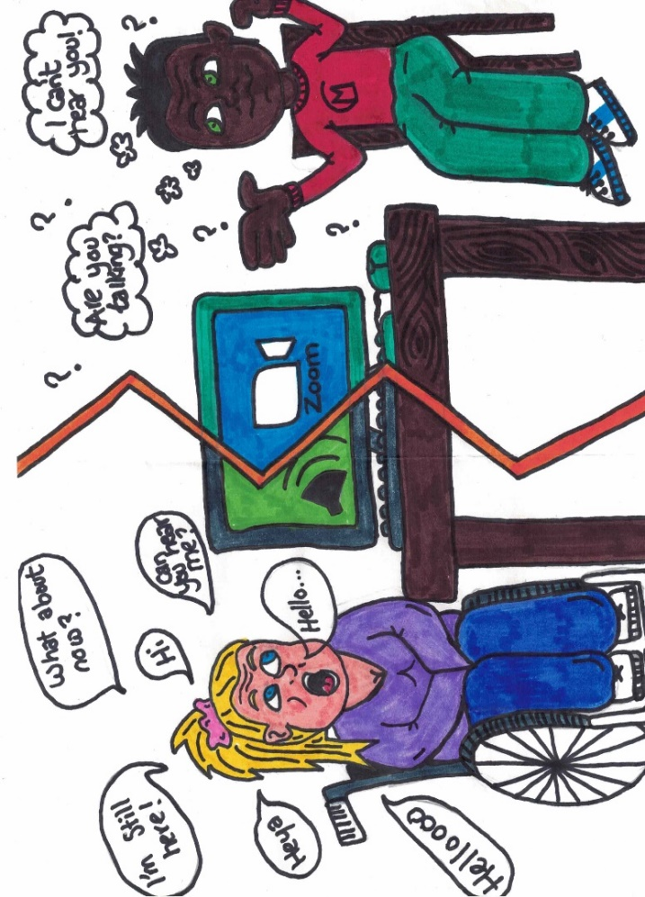
However, there was some evidence of the ‘digital divide’ too:
‘When my nan died, they told my grandad to get the death certificate online, but he had no idea how to do that.’
Some were able to adapt to the new situation and spoke with clear pride in getting to grips with new ways of doing things:
‘Everything has gone online now; I'm doing this for the first time and wasn’t sure if I would be able to get connected but somehow I did it.’
Calls to members also showed that many had problems with dealing with things online. A number described difficulties due to not having the equipment to do this and/or needing help to develop the skills to use it.
The option of using the telephone also presented a barrier for some people:
‘Everything on the phone is hard and useless to me as I have telephone anxiety.’
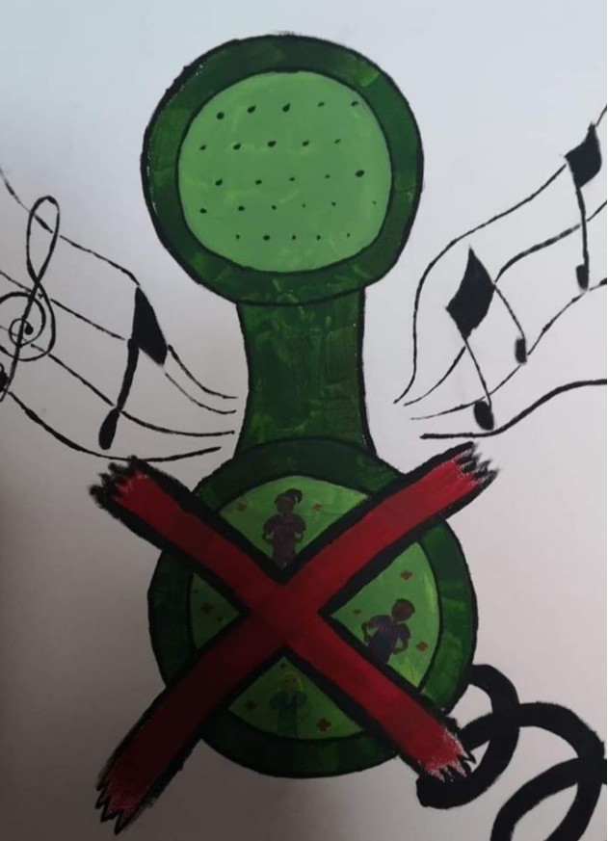

5. Loneliness and isolation

Loneliness and isolation were clear issues for Deaf and Disabled people in Merton as they were for the population as a whole, with comments including:
‘It’s like a prison. You’re on your own all day long, some can communicate with people online but what about people who do not have this access? And it’s not the same, being at home all the time not seeing people.’
‘When they did the CR4 thing (with the concern about the new strain of the virus and mass testing in the area) people refused to see me.’
‘Being in isolation and not seeing anyone for weeks on end has been really horrible.’
‘I've lost a lot of relationships with relatives and friends, some may never re-start.’
The calls to members revealed frequent concerns about isolation with 17, 26%, of 64 people spoken to indicating they were feeling lonely or isolated. Many of the members welcomed the opportunity to speak to someone and spent some time just talking. As a result, some started taking part in Merton CIL’s Craftivism and Chat meetings and Merton CIL continued to make ‘befriending’ calls to a small number of members through the lockdowns.

5.1 The impact of disability
Some people commented on the impact of disability on their experience:
‘You feel the isolation. If you’re in the vulnerable category and follow what they tell you to do it’s quite hard to keep yourself occupied if you are on your own to keep yourself upbeat.’
‘I have always been alone. I have always been lonely.’
‘It’s exacerbated the problems of isolation that Disabled people already have.’

As has been noted elsewhere, people who had been experiencing mental health problems before the pandemic experienced particular difficulty in dealing with loneliness and isolation:
‘It will leave a scar. It has made my issues from before all this worse… This has set back my mental health – I had started to feel more motivated before coronavirus, but I feel discouraged now.’
‘I've felt very isolated. I'm not a social person but I felt on my own and vulnerable. I just got some phone calls, and I don't have family or close friends.’
One person had a different perspective:
‘I make a distinction between loneliness and isolation. You can feel isolated without being lonely and you can feel lonely without being isolated. Generally, I don't experience a lot of feelings of loneliness, I think it’s just the way that my brain is, I'm OK with being alone. But I find that even though I don't feel lonely my mental health changes.’

5.2 What helped
Several people talked about what helped them to get through the situation. One person took comfort in focusing on the reason for shielding and isolation:
‘I have nobody around me – but in some ways I'm glad of this as there is no one around to infect me.’
Another how they kept a positive frame of mind:
‘I just lived day-by-day and in the moment. It was hard and felt like there was no future. I appreciated the little things like watching a good documentary or, cooking myself a meal… I used the internet a lot. It helped a lot with information learning about new things including literature, art, birds and many other things.’
Others felt that not having people meant it was essential to get out in the way that was accessible to them:
‘Do you stay indoors, and go stir crazy? Going out in the car helps blow off the cobwebs for a little bit, it’s like other people going out for a walk.’
And for three people, pets were their companions through the crisis:
‘I'm glad I have animals, I don't know what I’d do without them.’
‘I've got a dog and that’s good for getting me out if I'm indoors and don't want to do anything.’
‘I've got a cat who kept me sane.’

6. Other issues

6.1 Money, finance and benefits
Most people reported no great problems with money, finance and benefits. Three of the 10 survey respondents said they had problems and 4 of the 64 members called also referred to difficulties with money and benefits related to the pandemic situation. None of the people interviewed had experienced financial problems related to the coronavirus situation.
This is likely to be because many of Merton CIL’s members and service users were already receiving benefits before the pandemic. Some of the people who reported problems were at points where their entitlement had changed.
One person did refer to having had to spend a lot more during lockdowns. They said their obsessive-compulsive disorder (OCD) meant they bought large amounts of hygiene and cleaning products along with personal protective equipment (PPE).
Two of the people interviewed said they had delayed applying for assessments that they believed would have increased their incomes. One person believed their situation had changed the pandemic, but they had been not able to apply for a re-assessment. One had a health assessment for Universal Credit delayed, which meant they continued on a lower income for 6 months until the assessment was carried out by telephone and led to an increased award.

6.2 Health and social care services
Seven of the 10 people who replied to the survey said they had had difficulties with health services including groups, 10 of the people contacted through the calls to members and several of the interviewees. One interviewee said:
‘Getting health services was practically impossible and I missed having face-to-face.’
Another person had been receiving ongoing treatment before the pandemic and said their chemotherapy had been delayed. And another spoke about having a spoke about delaying getting advice about a cancer concern and then missing appointments:
‘I had an appointment in January when the covid rates were really high and I was just too scared to go. I thought the risk of covid was much higher than the unlikely possibility that I had cancer.’
A number had had difficulties accessing mental health services:
‘I was really struggling to get the support I needed with mental health and with health in general. That was really impactful on my health and how I was coping with life. I would have been in a better place in my life, and financially, if I’d got the support then.’
One person was discharged from mental health services during the pandemic and wanted to share their feelings about the need to remain engaged in their support in the form of a poem:
Don’t stop being
Involved in
Services in your
Care, make yourself
Heard and be more
Assertive,
Rage ahead. Don’t
Give up, use it as
Energy and ammunition!
Others had more positive experiences of mental health services:
‘When all this started, I dipped down quite a bit. I was fortunate I got some help from mental health services which got me back up.’
One person spoke about accessing mental health support online by telephone/online. One person said it was helpful that their recovery café had continued online during the lockdowns with sessions including art therapy, dance for psychotherapy and a book club. They said:
‘I found that very helpful, at least there has been some support.’
Dealing with services on the telephone or online was not a problem for most people. Some said it was easier than attending in person as they found it difficult to get to their GP and hospital, although others felt that appointments in person were preferable. Some had had to continue to attend medical appointments such as tests that needed to be carried out in person.
Several people spoke about using o support services including the NHS wheelchair service and orthotics. They described delays in getting repairs to a wheelchair and a delay in replacing a broken shower chair. Some people felt that the pandemic was used as an excuse for some of the delays they experienced.
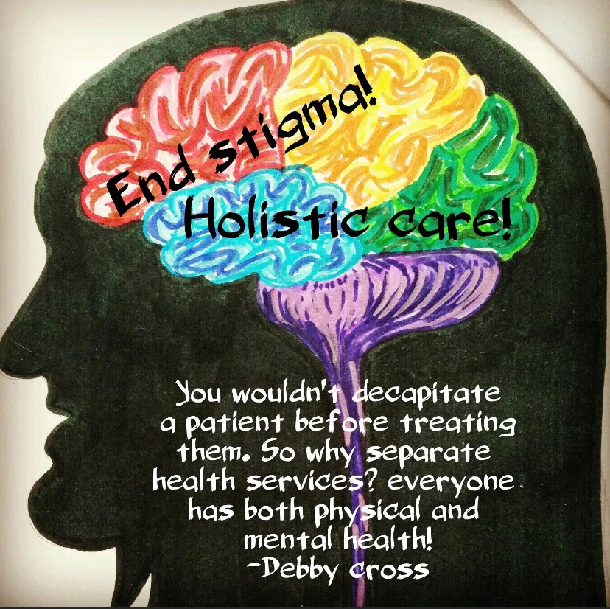
There were few reports of problems with social care services. One person reported difficulties with social care services in their response to the survey. They said many of their agency stopped supplying carers. Two members spoken to in the call round referred to problems with social care, with one saying how their care worker needed more time to do things like shopping and collecting prescriptions because of shops and chemists being so busy.
One of the people interviewed reported some concern about carers and home nursing staff not wearing facemasks properly.

Essential shopping
Many of the people we spoke to experienced difficulties with essential shopping along with most of the population in the early part of the pandemic. Seven of the 10 people who responded to the survey referred to difficulties with shopping along with 13 of the 64 members contacted. Many interviewees referred to the topic too:
‘At the start that was really scary because I didn’t know how I would be able to get groceries. ‘
‘Getting food was much more difficult.’
Online shopping proved useful for many people but several having found it difficult to get online delivery slots:
‘I was reassured by the supermarkets saying they would have priority slots and thought it would be easy to get them, but it wasn’t, and I had a couple of weeks where I was just fighting to get through on the phone. That was really tough and felt like a fight for survival.’
People who live on their own said it had been difficult to buy enough to meet the minimum cost for home deliveries and that shopping online was more expensive. One person said they had to include lots of alcoholic drinks in their shopping to achieve this.
Some people had not done online food shopping before the pandemic but said they had ‘got into it now’ and that it had become much easier to book deliveries, saying:
‘At least you’re not worrying about getting toilet roles now.’
Those who continued to visit shops expressed some concern about wearing masks and distancing. Concerns about masks went both ways, with some being worried by people around them not wearing masks, and others who were exempt from mask-wearing being challenged about not having one.
One person reported the positive experience of getting help with shopping through community support available in the borough:
‘It’s been lovely connecting with neighbours through the mutual aids.’

Housing
Only three of the people we spoke to experienced housing issues during the pandemic.
For one, the issue came about because of coronavirus. They had been sharing a house where one of the other tenants was going out and breaking restrictions which made them concerned about being exposed to the virus. They were fortunate in being able to use the home of a friend who was out of the country but had only expected to do so for a few weeks and only took a few things with them, which they found very stressful.
The other had been experiencing housing problems, including difficulties with neighbours, for some time before the pandemic. The pandemic meant there was no prospect of resolving the problems in the immediate future and they decided to move in with their family.

Access to information about the situation
People did not generally report any difficulties with accessing information about the virus and lockdown. However, one of the Deaf people interviewed said it had been difficult to access information about the virus, reflecting the wider concerns about these issues.

Vaccination
It is important to note that some people will not be able to have the vaccination due to a medical condition. One of the interviewees noted that they wanted to have the vaccine but would need reassurance that it would not affect their existing health conditions.
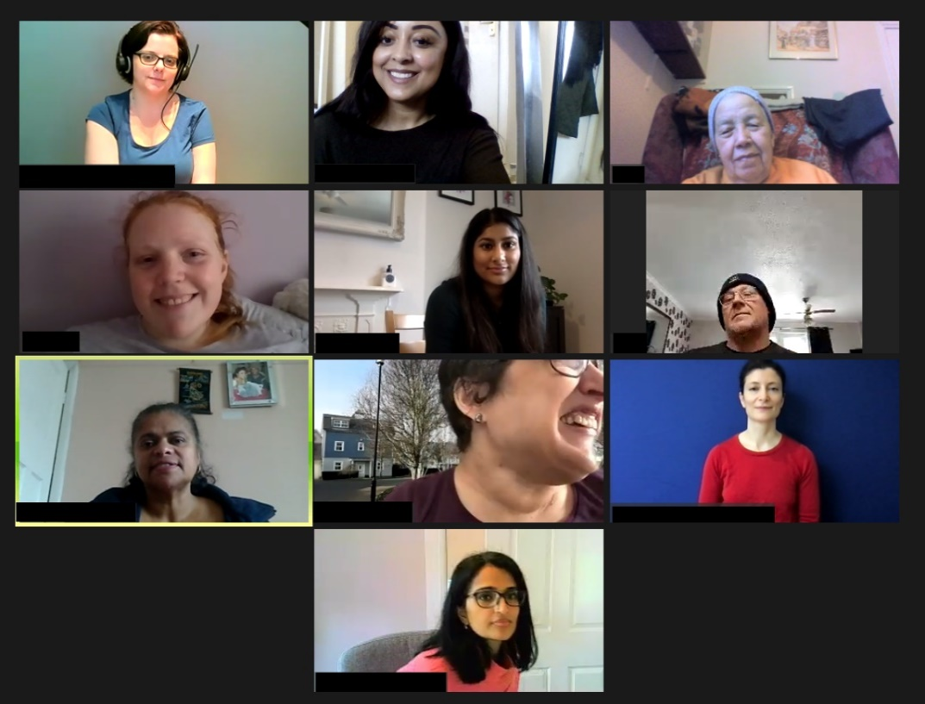
There was some reluctance among some of the people we spoke to based on concerns around the speed at which the vaccines have been developed and a view that information is biased.
One person described how they were not going to have a vaccination but changed their mind after a friend died of covid. Others were still making up their minds about whether to take it.
Merton CIL did assist the Clinical Commissioning Group by holding an online question and answer session for Deaf and Disabled people in March 2021 with a GP and a pharmacist.

7. The Merton CIL experience

Like all organisations and services, Merton CIL had to adapt to the challenges of the coronavirus and lockdowns. Face-to-face meetings with service users, often in their homes, are a key part of Merton CIL’s advice and advocacy service which had to be stopped in March 2020 with contact continuing by telephone and online video calls on systems like Zoom and Teams. Monthly Craftivism and Chat meetings are another key part of Merton CIL’s offer to Deaf and Disabled people in the borough, and these have also been held online for over a year with extra sessions added to help people through the lockdowns.
Meetings of Merton CIL’s board of trustees have also been held online throughout this time. The Annual General Meeting and My Voice Matters meeting were also held online, successfully working with the Ignite Me drama group to build a discussion about issues around the pandemic and access issues.
Staff moved to working from home in March 2020 and are only just starting to return to the office in June 2021.
This section captures the views of 5 of Merton CIL’s 8 staff of their experiences of working through the pandemic.

Working from home
Merton CIL had some preparation for the lockdown with a gap of around a month between having to leave an existing office in November 2019 and a new office being ready for use in January 2020, and ironically having to return to home working just a few weeks later for a period that would last for over a year.
This meant the organisation was aware that some of its IT infrastructure was not best suited to home working. New approaches like video meetings were soon in place but it would take a few before new funding meant Merton CIL could make sure every staff member had a work laptop and software like Office 365 and MS Teams were in place.
Staff reported some difficulty adapting to the new way of working. Some described difficulties with boundaries between work and home life, with noise and interruptions from others living with them:
‘I missed softer communications and office interactions and spontaneous conversations with colleagues, as now all pre-planned and pre-determined.’
‘The pandemic and new virtual environment felt like continually working in virtual world and feeling of not getting everything done.’
‘Work feels a lot more admin-based and less human-centred at times.’
‘I enjoy working at home, but family sometimes forget I am at work and too much noise and interruptions.’
One person noted that it made coordinating work with other organisations considerably more difficult.
Some found the experience more positive:
‘I enjoyed working from home. It made juggling work and home much easier, and I managed to work and do home-schooling without having to compromise.’
‘I enjoyed hybrid working.’

Working with service users
Merton CIL’s frontline staff in the advice and advocacy service described the move to working with service users solely by telephone and online as difficult. It involved the need to teach some service users how to use new technology. Work with other, particularly younger, service users, showed the need for Merton CIL to modernise and it was behind the wave in not using platforms like WhatsApp. One person said they thought this highlighted that Merton CIL had few users who were under 30.
The staff thought that some service users preferred working in this way. Some who would have come to the office for appointments found it easier not having to deal with access barriers involved in travelling. Service users did not miss any appointments this, compared with 36 in 2019 – 20202. However, it is well recognised that telephone and video calls limit how much can be picked up from body language and non-verbal cues and caseworkers found this a particular drawback in working this way with service users.
Staff also found that they were able to fit more meetings into a day because of not having to travel between people’s homes and the office. However, the downside of this was that online meetings could be more draining than meeting in person.
Overall, staff saw the benefits of online contact with service users and recognised it would be useful to maintain a hybrid approach into the future.
In terms of the issues staff worked on with service users, staff felt there was an increased need for benefits advice. Staff said that users seemed to be under greater financial strain and there was an increased need for food vouchers. Some users found dealing with telephone assessments for benefits difficult: they sometimes only received a couple of days’ notice of telephone assessments and experienced considerable anxiety before they took place. Users also found that assessors for Personal Independence Payments (PIP) came across as supportive on the telephone, but this was not reflected in their reports, which left them feeling more anxious and marginalised. People receiving Employment Support Allowance (ESA) were particularly anxious about having to go back to JobCentres and or a workplace while they still felt at risk from the virus. Merton CIL’s caseworkers gave extensive support with all these issues and service users appear to have appreciated the support.
One caseworker noted how difficult it is for service users to deal with lots of different people in different departments and a lack of individual contact points within services. This is an issue that pre-dates the pandemic but may have become more of an issue when times have been as difficult as they have been in 2020 and 2021.
There was also an observation that the pandemic and fears about the virus lead to an increase in mental health issues and required a new awareness of issues around mental health and loneliness from staff. This may need to be continued beyond the pandemic and may need to be supported with training on skills such as counselling and recognition of the need for caseworkers to have access to mental health support.
Staff received a strong sense of appreciation from service users who felt they had someone listening to them and on their side. As well as the advice and advocacy service, members seemed to get a lot from the monthly Craftivism and Chat sessions with the opportunity for social interaction and to discuss issues. We also added to the monthly sessions with extra Craftivism and Chat meetings designed to support wellbeing with activities including yoga and mindfulness. We also sent packs with art and craft materials to support people to take part in in the meetings. Attendance at Craftivism and Chat meetings online rose at the start of the pandemic, although this did drop back down as time went on.
Topics covered during the pandemic included mask wearing and changes in the physical environment and streetscape to support social distancing. As a result, Merton CIL did some work contacting large shops in the area to remind them that many Disabled people were except from wearing masks, and that the reason for this might not be visible. Additionally, a new group of Access Champions was set up during the second lockdown which has given input on planning applications and is setting up a community journalism website.

8. Conclusions and The Future

In many ways there have been few great differences between the experiences of Deaf and Disabled people in Merton compared with Deaf and Disabled people elsewhere in the country. For some, being Deaf or Disabled, the experience of living with a disability/impairment prepared them for the difficulties of 2020 and 2021. Several members compared their everyday experiences of barriers, exclusion and isolation to those that the everyone experienced in lockdown. This suggests that a key message coming out of the pandemic is that as freedom returns it must be freedom for everyone, including Deaf and Disabled people. Much is being said at the moment about the ‘levelling up agenda’ and ensuring that levelling includes removing the barriers that cause inequality for Deaf and Disabled people.
Another clear message from Merton CIL’s research is that mental health has become more evident than ever as a key issue where people need support. The pandemic seems to have highlighted that mental health can be a dimension in all situations and it is one that organisations involved in providing services and support need to maintain awareness of at all times.
In particular, as we emerge from what has hopefully been the worst of the pandemic, services and support need to be understanding that concerns and anxieties about coronavirus are likely to continue for some time and these feelings must be respected.
Mental health problems may often be a hidden impairment as are many hidden impairments. This caused problems for a number of the people who contributed to this report and reflects broader experiences of people with hidden impairments during the pandemic and the situation has served to highlight the difficulties people experienced well before coronavirus. Awareness and understanding of the barriers experienced by people with hidden impairments is a beneficial learning point that may come out of the pandemic.
The shift to online services, meetings and working from home had a great impact for everyone during the pandemic, enabling many things to continue that may otherwise have had to stop. This has not suited everyone, but for many Deaf and Disabled people it has meant the opportunity to take part and be involved in things that have previously been difficult or impossible. This is not going to be right for everyone, and for some people it might be right at some times but not at others, but now that it has been shown that online approaches can work it is essential that this remains an option. This is something that may become more complex, with meetings and events that include people present in person and online likely to be more complex than events where either everyone is there in person or everyone is online, and it is likely to take some work to get this right.

Recommendations
- Put equality for Deaf and Disabled people and all disadvantaged groups at the heart of recovery and development programmes coming out of the pandemic, including recognition of issues around intersectionality.
- Put awareness and understanding of mental health at the core of services and for Deaf and Disabled people along with work to promote awareness of these issues and their impact.
- Work to develop awareness and understanding of the situation of people with hidden impairments.
- Maintain a combined offer of in-person, telephone and online services and participation.
- Services and support need to be available for Deaf and Disabled people who need to develop their digital skill.
- Access will always be a concern for Deaf and Disabled people, and it is essential there is full consultation about any changes to the built environment/streetscape, especially when changes are being made quickly as happened in the pandemic.
We believe these recommendations are relevant to the Council, health, voluntary sector services and the private sector. This includes Merton CIL itself which will be starting a strategic planning process in late 2021 and will include consideration of these points.

Report by Michael Turner, Policy and Strategy Manager, Merton Centre for Independent Living.
Email: michael@mertoncil.org.uk
www.mertoncil.org.uk
@MertonCIL
Registered Charity Number: 1152825 - Company Number: 7645926

One member of staff was not available and the Policy and Strategy Manager did not contribute as they worked on the report.
https://democracy.merton.gov.uk/documents/b13610/Presentations%20given%20at%20the%20meeting%20Monday%2026-Apr-2021%2019.15%20Healthier%20Communities%20and%20Older%20People.pdf?T=9
https://www.ons.gov.uk/peoplepopulationandcommunity/birthsdeathsandmarriages/deaths/bulletins/deathsinvolvingcovid19bylocalareasanddeprivation/deathsoccurringbetween1marchand31july2020#local-authorities
https://www.ons.gov.uk/peoplepopulationandcommunity/birthsdeathsandmarriages/deaths/articles/coronaviruscovid19relateddeathsbydisabilitystatusenglandandwales/24januaryto20november2020
https://committees.parliament.uk/publications/4068/documents/40461/default/
https://www.inclusionlondon.org.uk/disability-in-london/coronavirus-updates-and-information/campaigns-news-during-coronavirus-crisis/abandoned-forgotten-and-ignored-the-impact-of-covid-19-on-disabled-people/
https://www.inclusionlondon.org.uk/disability-in-london/coronavirus-updates-and-information/campaigns-news-during-coronavirus-crisis/locked-down-and-abandoned-disabled-peoples-experience-of-covid-19/
https://www.sisofrida.org/report-disabled-womens-perspectives-on-independent-living-during-the-pandemic/
https://www.disabilityrightsuk.org/news/2021/april/covid-causing-huge-rise-disability
For example, https://www.icaew.com/library/subject-gateways/law/legal-alert/2021-02/new-law-employers-need-to-consider-whether-long-covid-is-a-disability

