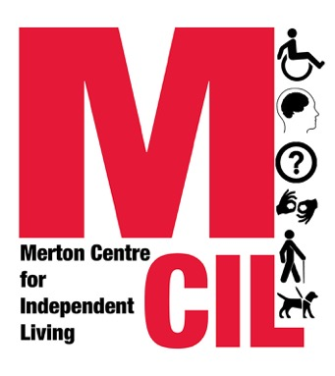
Merton Council elections 2022
Merton CIL pledge form

Please return by 9.00 am on Friday 29 April 2022 to: info@mertoncil.org.uk
And please tweet your responses with #disabilitymattersmerton and @MertonCIL

Name:
Party:
Ward standing in:
I support the following pledges put forward by Merton Centre for Independent Living and Deaf and Disabled people in Merton:

1. To co-produce policies and services with Deaf and Disabled people.
2. To review charges for council home care services.

3. To support efforts to fully involve service users in the new Integrated Care System, particularly in relation to mental health services.

4. To work to remove barriers to access, including specifically to review where pavement parking is allowed and increasing enforcement to reduce illegal parking on pavements.

5. To explore how to reach the existing target of 10% of new homes being wheelchair accessible and the other 90% meeting the general access standard.

6. To make all parts of Merton equally good places to live and work.

