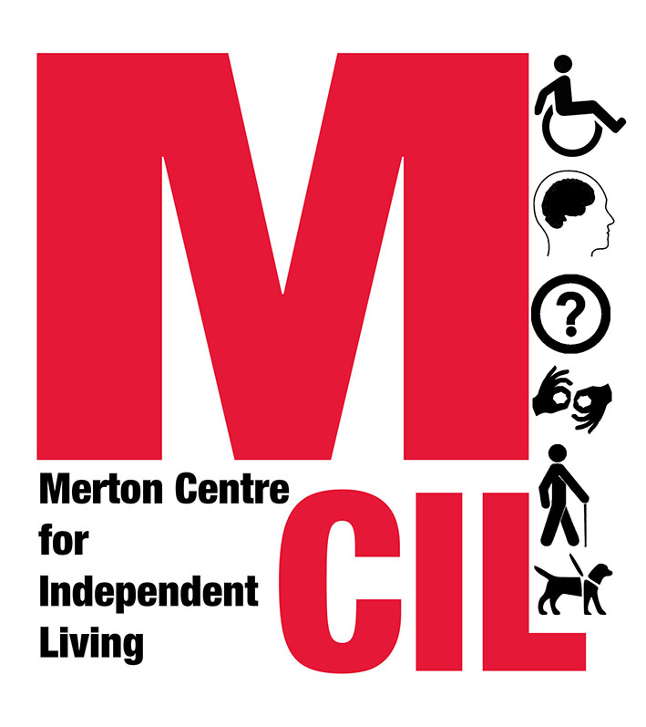

Merton CIL’s response to the Council’s Housing Delivery Strategy Consultation

October 2021

Background

About Merton CIL
Merton CIL is a pan-Disability user-led Deaf and Disabled People’s Organisation that has been supporting Deaf and Disabled People in the borough since 2008. We work with people with all types of impairment including physical impairments, sensory impairments, mental health service users, people with learning difficulties and people with chronic illness or long term ill-health. Many of our service users have more than one impairment, and many are also carers and/or parents. Deaf and Disabled People do not have to be members to use our services but we do have an ever-growing membership who shape our direction and focus as an organisation. At the end of 2020 Merton CIL had 362 members.
In 2020 our advice and advocacy service worked with 265, providing just over 1,000 sessions of advice on a range of issues including social care, benefits, and hate crime. Many of the service users we support experience problems with a range of issues that are often interlinked. We also reached over 1,000 people through events and outreach, and just over 3,000 people followed us across our social media platforms.
While Merton CIL’s main role is to provide advice and advocacy support for individuals, we also engage with local consultation and co-production to work with the Council and the voluntary sector in the borough.

Deaf and Disabled people in Merton
The London Borough of Merton has a population of 209,421 people. According to the 2011 census, 25,232 residents felt their day-to-day activities were limited a little or a lot, about 12% of the population.
The Greater London Authority (GLA) estimates that by 2020 Merton’s population had increased by just over 1% to 211,787, which would bring the number of Deaf and Disabled people to approximately 25,484. The GLA projects that Merton’s population will increase to 225,157 people by 2031. If the proportion of Deaf and Disabled people remains at 12%, this would mean there will be 27,018 Deaf and Disabled people in Merton in 2031. The likelihood is that the ageing population will mean the proportion of Deaf and Disabled people will increase.
The Council’s disability profile gives the following figures about different types of impairment/disability in 2018:
- 27,300 Deaf people/people with hearing loss
- 2,400 people with visual impairments
- 13,000 people with physical impairments aged 18 – 65
- 4,800 people over 65 with mobility impairments
- 3,900 people with learning difficulties.

Overview
Many of the issues covered in the strategy do not come within Merton CIL’s expertise on housing. However, we believe that the strategy is severely lacking in its consideration of the delivery of housing for Deaf and Disabled people.
While it is welcome that the strategy includes a section on housing for people with particular needs, this is not underpinned by the overall strategy for building new accessible housing. Merton CIL is surprised that there is no mention of the Building Regulations Part M4(2) for general accessibility and Part M4 (3) for full wheelchair access in new housing.
The section notes (paragraph 3.5) that the target for new homes in the London Plan was not met in 2018 – 2019. It should also be recorded that the most recent figures for the targets for new accessible housing in the last three Annual Monitoring Reports for the London Plan published by the Mayor show these have been missed:
Year | Merton | London | Merton | London
2018 – 19 | 17.1% | 73.5% | 7.4% | 9.3%
2017 – 18 | 23% | 66% | 3% | 7%
2016 – 17 | 92% | 73% | 3% | 9%
Issues with the targets are clearly not specific to Merton, but, except for the general accessibility standard in 2016 – 2017, they both missed the target and missed them at rates above the level at which they are missed in London as a whole.
Merton CIL is concerned that the strategy makes no reference to these issues and believes it is essential for them to be addressed by the strategy. We would like to see consideration given to how these and other targets are delivered in the future and what will be done to remedy the situation years when targets.
In 2018 the Equality and Human Rights Commission (EHRC) published a report called Housing and disabled people: Britain's hidden crisis which showed the scale of the housing problems faced by Deaf and Disabled people. The report made a range of recommendations for central and local government and called for councils to:
- Increase and improve data collection about accessible housing
- Introduce accessible housing registers
- Remove bureaucratic barriers to making adaptations
We believe these points should fall within the housing delivery strategy, and that the Council should adopt the full range of recommendations made by the EHRC and use its accompanying tool kit for local authorities to implement its recommendations.

Responses to sections of the strategy

Section 2: The vision
Given the acute lack of accessible housing, as identified by the Equality and Human Rights Commission, Merton CIL believes that the vision of the housing delivery strategy should explicitly state that the ‘match of identified need’ includes all housing will meet accessibility standards.
Affordability is also a key issue to Deaf and Disabled people, as it is to all sections of the community, and we believe this should also be included in the vision. Delivery of quality housing will not resolve the housing crisis if it is unaffordable.

Section 3: Background and context
This section gives no consideration of the availability of accessible housing in the borough. This is a serious omission that needs to be addressed.
As far as we are aware, the Council has not acted on the Equality and Human Rights Commission’s recommendation in 2018 that councils should monitor the availability of accessible social housing in the borough. We believe this would have given essential further detail to the background and context of this strategy.

Section 4: What does Merton need?
The analysis of the housing register highlights again that the Council has not acted on the Equality and Human Rights Commission’s recommendation that councils should monitor the situation of Disabled people on their housing registers. The Commission said local authorities should use best practice in the use of accessible housing registers along with increasing their knowledge of accessible housing stock.
We are also concerned by the assertion in the strategy that housing demand is relatively stable. It is accurate to say this looking at the three years 2017 – 2020 as is done in the strategy but looking at a longer time frame using statistics from central government, it increased year on year from 7,625 in 2014 to the peak of over 10,215 in 2018/19. This represented a 34% increase compared with a 4.7% decrease London-wide in the same period (although we note that differing waiting list policies between different boroughs).
We are surprised that point 4.24 makes such a vague point that:
‘consideration needs to be given to the supply of decent and accessible accommodation, across all tenures, that can be adapted to help people live at home for as long as possible and where additional care and support can be increased and decreased as necessary.’
The point about housing that can be adapted is covered by Part M4(2) of the building regulations and the Council’s target that 90% of new housing should meet this standard, with the remaining 10% meeting the higher standard for wheelchair accessibility, as discussed above. It is concerning that the Building Regulation’s provisions for accessible housing are not referenced here, or elsewhere in the strategy.

Section 6: Delivering the Right New Homes
Merton CIL supports the emphasis on affordability as physically accessible homes will remain inaccessible if they are not affordable. We would just add that it is well documented that Deaf and Disabled people are statistically amongst the lowest paid and least well off in society, so are likely to experience difficulties around the affordability of housing.

Section 8: Direct intervention
We are interested in the ideas of self-build and community built housing (point 8.11) and would be keen to explore how Deaf and Disabled people might be involved in developing small scale housing as a way to ensure new housing is truly accessible. It is important to note that many believe the building regulations need to be improved and a government review is currently in progress.

Section 9. Density and Intensification
Merton CIL has a general concern about high-density housing, which we know the Council is exploring through the local plan. This generally means high rise building and this has particular implications for many Deaf and Disabled people. Any plans for high density/high rise housing needs to be accompanied by plans to ensure accessibility and safety.
On point 9.5 regarding climate change issues, we would make the point that meeting standards on accessibility reduces the need for remedial building work and the impact this has on the environment.

Section 10. Housing for particular needs
Again, the lack of any reference to the Part M regulations and the Council’s existing targets is a concern.
Points 10.4 and 10.5 refer to interventions around aids and adaptions and Disabled Facilities Grants and the need to link housing policy and service to Adult Social Care and other services. We would recommend the strategy includes a requirement to develop a strategy for improving and increasing housing for Deaf and Disabled people in the borough. Merton CIL believes a holistic approach to the housing crisis is needed to effectively address the housing crisis for Deaf and Disabled people. This would be an opportunity to address issues around occupational therapy and the vital role it plays in aids and adaptations, the way medical assessments for the waiting list and homelessness applications and repairs and maintenance, all of which are significant concerns to Deaf and Disabled people.
This all links to the next section.
Merton CIL has done little work in relation to care homes or supported living but agrees with the plans in the strategy about the need for work to clarify the best options for people and develop appropriate accommodation with the required support.

Section 11. Using and improving existing stock
This section seems to focus on regeneration without any consideration of the benefits of refurbishment. We believe there are cases where refurbishment may be a preferable option, involving less disruption to people’s lives, which can have a particular impact on Deaf and Disabled people and has less impact on the environment.

Michael Turner
Policy and Strategy Manager
Merton CIL
michael@mertoncil.org.uk

https://data.merton.gov.uk/
https://maps.london.gov.uk/population-projections/
https://www.merton.gov.uk/assets/Documents/www2/Merton%20Disability%20Health%20and%20Care%20Profile%20October%202018%20V4.pdf
https://www.london.gov.uk/sites/default/files/amr_16_final.pdf
https://www.london.gov.uk/sites/default/files/amr_15_final.pdf
https://www.london.gov.uk/sites/default/files/amr_14_final.pdf
https://www.equalityhumanrights.com/en/publication-download/housing-and-disabled-people-britains-hidden-crisis
https://www.equalityhumanrights.com/en/publication-download/housing-and-disabled-people-toolkit-local-authorities-england

