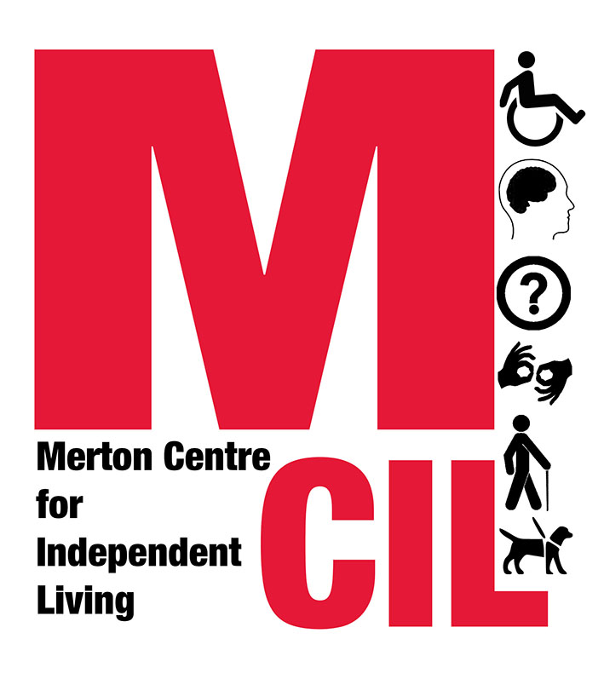

Role Description and Person Specification

Role title | Trustee
Reporting to | Chair

Overall Purpose of Role

Trustees are ultimately responsible for the organisation including setting the strategic direction of the organisation and ensuring the organisation acts lawfully and furthers its charitable aims
About Merton CIL

Merton CIL is a disabled people’s user-led organisation. This means that at least 75% of our board are disabled people. We promote the inclusion, choice, and independence of disabled people in Merton. We were established to provide a voice for disabled people in the borough and to provide support to disabled people in all areas of their lives.

Key Tasks and Responsibilities

- To inform and set the strategic direction of MCIL based on lived experience and member and service user feedback
- Attend board meetings, Annual General Meeting, events and other meetings or committees as required
- Ensure policies and procedures are followed as agreed by directors
- To be responsible for overseeing MCIL’s finances and resources
- To support MCIL with fundraising and engagement
- To ensure risks to MCIL are identified, managed and mitigated
- Keep up to date and complies with regulations and legislation.

Person Specification

We are looking for someone who can actively contribute their views, brings lived experience to the trustee role, and is able to question and challenge the organisation and always work in the best interests of Merton CIL

We can offer training in disability equality, the support of your colleagues on the board, and we will work with you to identify any access needs that we can support you with.
Essential
- Understand and actively promote the ethos and values of MCIL
- Experience of disability
- Effective Communication Skills
- Ability to work effectively as a member of a board
- Ability to be flexible and responsive to change
- Ability to handle with discretion information which may be confidential or sensitive

Desirable
In addition we would also value the following skills and experience:

- Legal, HR, IT or Financial backgrounds
- Experience in Mental Health or Learning Disability
- From a BME or other minority background
- Relevant life experience, degree level qualification or equivalent level professional experience

