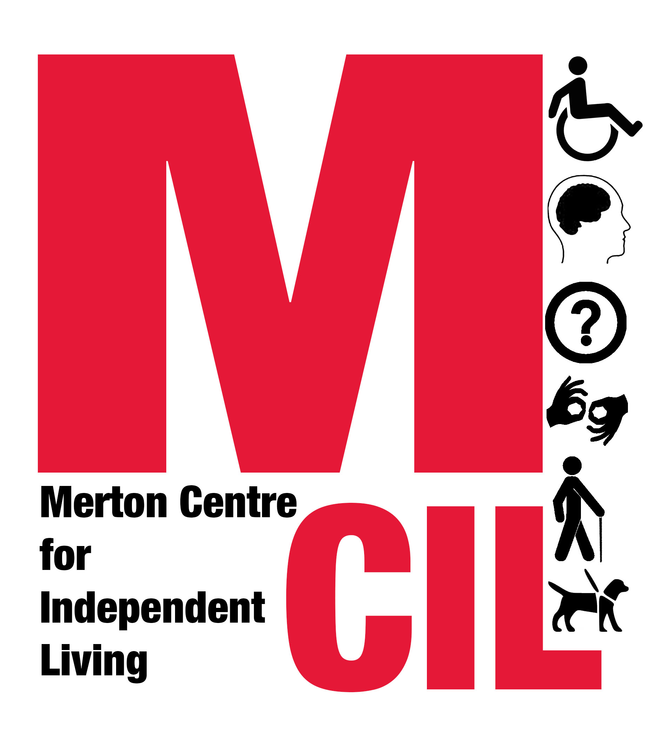
✔ Please help us with our monitoring information

We’re all different. We need different things. ‘Equality’ and ‘diversity’ are terms that basically mean we should all get the right services, whoever we are. It’s not about special treatment, it’s about the right treatment for everyone. And you can help make sure it happens because monitoring shows us if certain people aren’t making the most of what we have to offer. At Merton CIL we gather monitoring information to help us identify what works well and what doesn’t in our organisation. It also helps us check that other services and organisations are treating everyone fairly too. This helps us to provide better services to you.

The information we gather is confidential. Please tick the boxes as appropriate

Gender
Male Female
If you prefer to use your own word, please specify ........................
Prefer not to say

Disability
A disabled person A parent of a disabled child
A carer of a disabled adult A non-disabled person
If you prefer to use your own word, please specify ........................
Prefer not to say

Disabled people, please tick as many boxes as you think are relevant to you:
Learning or intellectual disability Long-term ill health
Mental Health Service User / Survivor Physical disability
Visual Impairment / Sight Loss Deaf / Hearing Loss
If you prefer to use your own word, please specify ........................
Other, please specify ........................
Prefer not to say
Age
Date of Birth_____/_____/______
Aged 17 or under Aged 55-64
Aged 18-24 Aged 65-74
Aged 25-34 Aged 75-84
Aged 35-44 Aged over 85 years
Aged 45-54 Prefer not to say

Sexuality
Bisexual Gay man
Gay woman/lesbian Heterosexual/straight
If you prefer to use your own word, please specify ........................
Other, please specify ........................
Prefer not to say

Ethnicity
Asian or Asian-British
Bangladeshi Chinese Indian Pakistani
Any other Asian Background, Please specify ........................
Black or Black British
African Caribbean
Any other Black background, please specify ..........................
Mixed / Multiple Ethnic Groups
Mixed Ethnic Background
White
British Irish Gypsy or Traveller
Any other White Background, Please specify ........................
Other ethnic Group
Arab
Any other Ethnic Background, Please specify ........................
If you prefer to use your own word, please specify ................
Prefer not to say

Religion
Buddhist Christian
Hindu Jewish
Muslim Sikh
No religion
If you prefer to use your own word, please specify ........................
Other Religion, please specify …………………………..
Prefer not to say
Marital Status
Single (never married and never registered in a same-sex civil partnership)
Married or registered in a same-sex civil partnership
Separated, but still legally married or still legally in a civil partnership
Divorced or formerly in a civil partnership which is now legally dissolved
Widowed or surviving partner from a civil partnership
Co-habiting
Prefer not to say

Housing
Bed & breakfast tenant Friends/ relatives Homeless
Hostel Housing Association Mortgage
Own outright Private tenant Rent-free
Shared ownership Prefer not to say
Other (please specify) ............................

If you are in a Housing Association, is it...
Circle Housing (CHMP) London and Quadrant (L&Q)
Moat Wandle
Other (please specify) ............................

Employment
Please tick as many boxes as are relevant
Employed Looking for work Self-employed
Studying Unemployed Volunteering
If you prefer to use your own word, please specify ............................
Prefer not to say

Monthly Income
Under £400 £400 - £599 £600 - £999
£1000 - £1499 £1500 - £1999 £2000 - £2499
£2500 - £2999 Over £3000 Don’t know
Prefer not to say

Thank you!
Office use only: Advice Advocacy Hate Crime
Member Peer Support Staff
Volunteer
[ ---------/--------- ] Reference

[---------------------] Date

