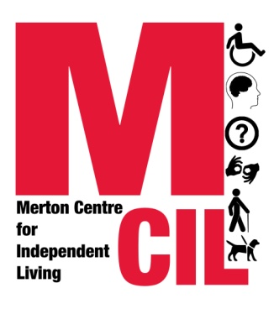
✔ Please help us with our monitoring information
We’re all different. We need different things. We should all get the right services, whoever we are. You can help make sure it happens because monitoring shows us if certain people aren’t making the most of what we have to offer. At Merton CIL we gather monitoring information to help us identify what works well and what doesn’t in our organisation. It also helps us check that other services and organisations are treating everyone fairly too. This helps us to provide better services to you.

The information we gather is confidential and if you decide you no longer want us to know this information then we will delete it.

Gender
Male Female Transgender
If you prefer to use your own word, please specify ........................
Prefer not to say

Transgender is an umbrella description which refers to people whose gender identify is different to their assigned gender at birth. Do you identify as transgender?
Yes No Prefer not to say

Disability
A disabled person A parent of a disabled child
A carer of a disabled adult A non-disabled person
If you prefer to use your own word, please specify ........................
Prefer not to say

Disabled people, please tick as many boxes as you think are relevant to you:
Autistic Spectrum Cognitive Disability
Deaf / Hearing Loss Mental Health Service User/Survivor
Learning or intellectual disability Long-term ill health
Physical disability Visual Impairment / Sight Loss
Other/If you prefer to use your own word, please specify .................
Prefer not to say
Age
Aged 17 or under Aged 55-64
Aged 18-24 Aged 65-74
Aged 25-34 Aged 75-84
Aged 35-44 Aged over 85 years
Aged 45-54 Prefer not to say

Sexuality
Bisexual Gay man
Gay woman/lesbian Heterosexual/straight
If you prefer to use your own word, please specify ........................
Other, please specify ........................
Prefer not to say

Ethnicity
Asian or Asian-British
Bangladeshi Chinese Indian Pakistani
Any other Asian Background, Please specify ........................

Black or Black British
African Caribbean
Any other Black background, please specify ..........................

Mixed / Multiple Ethnic Groups
Mixed Ethnic Background

White
British Irish Gypsy or Traveller
Any other White Background, Please specify ........................

Other ethnic Group
Arab White European
Any other European background
Any other Ethnic Background, Please specify ..............
If you prefer to use your own word, please specify ................
Prefer not to say

Religion
Buddhist Christian
Hindu Jewish
Muslim Sikh
No religion Other Religion, please specify …………
If you prefer to use your own word, please specify ........................
Prefer not to say

Date:

Thank you!
Office use only: Advice & Advocacy Member
Staff Volunteer / Trustee

Reference [ ---------/--------- ]

Worker supporting_____________________________

