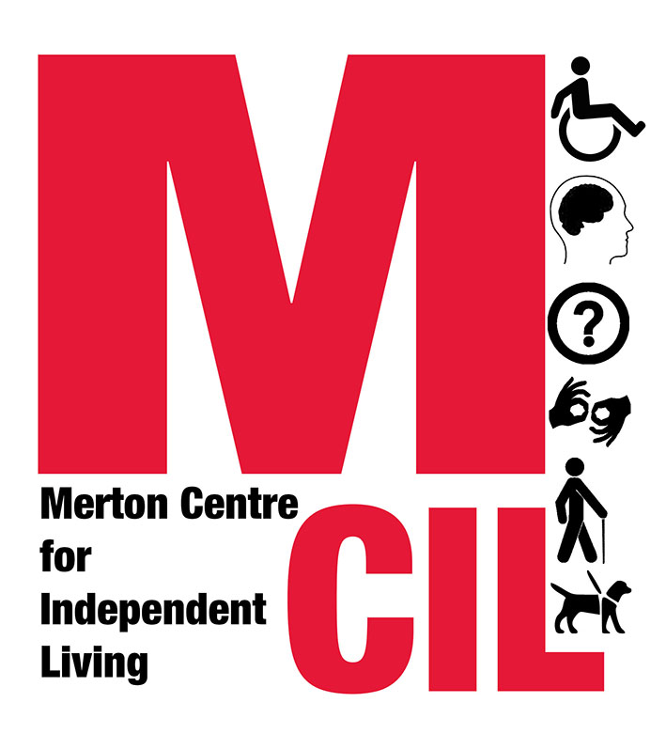

Job Description and Person Specification

Role: Office Administrator

Reporting To: Communications & Office Manager

Hours: Negotiable - 13 to 16 hours per week

Salary: £20,144 pro rata

Start Date: 24th May 2021 or as soon as possible thereafter

Contract Type: This is a fixed term 6-month contract with the possibility of extension, dependent upon funding

This post is subject to a satisfactory Enhanced DBS (Disclosure and Barring Service) check.

Overall Purpose of Role

To provide administrative support to the organisation, as well as board of trustees. This role is key to ensuring that the organisation runs smoothly.

About Merton CIL

Merton CIL is a user-led organisation promoting the independence and inclusion of Deaf and Disabled people in Merton and the wider community. We were established to provide a voice for Deaf and Disabled people in the borough and to provide support to Deaf and Disabled people in all areas of their lives.

Key Tasks and Responsibilities
- Being the first point of contact for the organisation – welcoming, assisting and directing callers and visitors and recording all relevant information on our database.
- Providing administartive support to the Senior Management Team and on occasion board of trustees.
- Supporting with the planning and running of monthly Craftivism and Chat groups and support sessions and recording all relevant information on our database.
- Supporting with financial administartion including invoices and PO systems.
- Supporting with research and gathering content for toolkits and guides throughout the pandemic and thereafter.
- Supporting with content creation for social media and website.
- Maintaining and updating membership records.
- Managing and conducting wellbeing check in calls to isolated service users.
- Supporting with the advice and advocacy service case allocations process and case research.
- Providing support to volunteers and recording all volunteer contact on our database.
- Supporting with general administrative duties including taking and typing up minutes where required.
- General office management support such as monitoring and maintaining stationery supplies, checking prices, checking off deliveries etc.
- Supporting with the promotion of the organisation.
- Supporting with monitoring and evaluation.
- Supporting with administartion around recruitment including but not limited to promotion of vacancies, arranging interviews and reference requests.
- Supporting implementation of our Health and Safety policy.
- To carry out the duties of the post within an equal opportunities framework and adhere to all Merton CILs policies and guidelines.
- To undertake such duties as from time to time may reasonably be required.
- This job description reflects the requirements of the post at the time of writing. The needs and circumstances may change over time and therefore the Job Description may need to be reviewed in the light of any such changes which may occur.

Person Specification

Essential
- Experience in an administrative/organisational role.
- Experience developing and maintaining relationships.
- Self-motivated and keen to learn and develop new skills and knowledge.
- Capable of working supervised and unsupervised.
- Excellent written and oral communication skills.
- Ability to be welcoming and compassionate.
- Ability to remain calm and work effectively under pressure.
- Ability to be flexible and responsive to change.
- Committed to fighting for justice.
- Committed to valuing people’s lived experience.
- Committed to working to the Social Model of Disability.
- Ability to work collaboratively as part of a team.
- Ability to maintain confidentiality.
- Strong IT skills (including Word, Excel, Outlook).
- Must have a strong personal commitment to supporting people across the spectrum of disability or health issues and to supporting people from a variety of ethnic and social groups.

Desirable
- A Deaf or Disabled person or a person living with a long-term health condition or individual with lived experience of disability.
- An understanding of the Merton voluntary sector and local authority structures.

Merton CIL is committed to equality, diversity and reflecting the communities we serve. We particularly welcome applications from individuals from Black, Asian, and Minority Ethnic communities.

Closing date for applications: 9:00am on 10th May 2021.

Interviews will take on either 13th, 14th, 17th or 18th May via Zoom.

Candidates invited to interview will be informed by 5pm on Tuesday 11th May 2021.

Start date: 24th May 2021 or as soon as possible thereafter.

If you require additional support completing this application due to an access need, or if you would like further information about the role or the application process, please get in touch on 0203 397 3119.

Please apply with:
- A completed application form
- A completed personal details form
to info@mertoncil.org.uk

