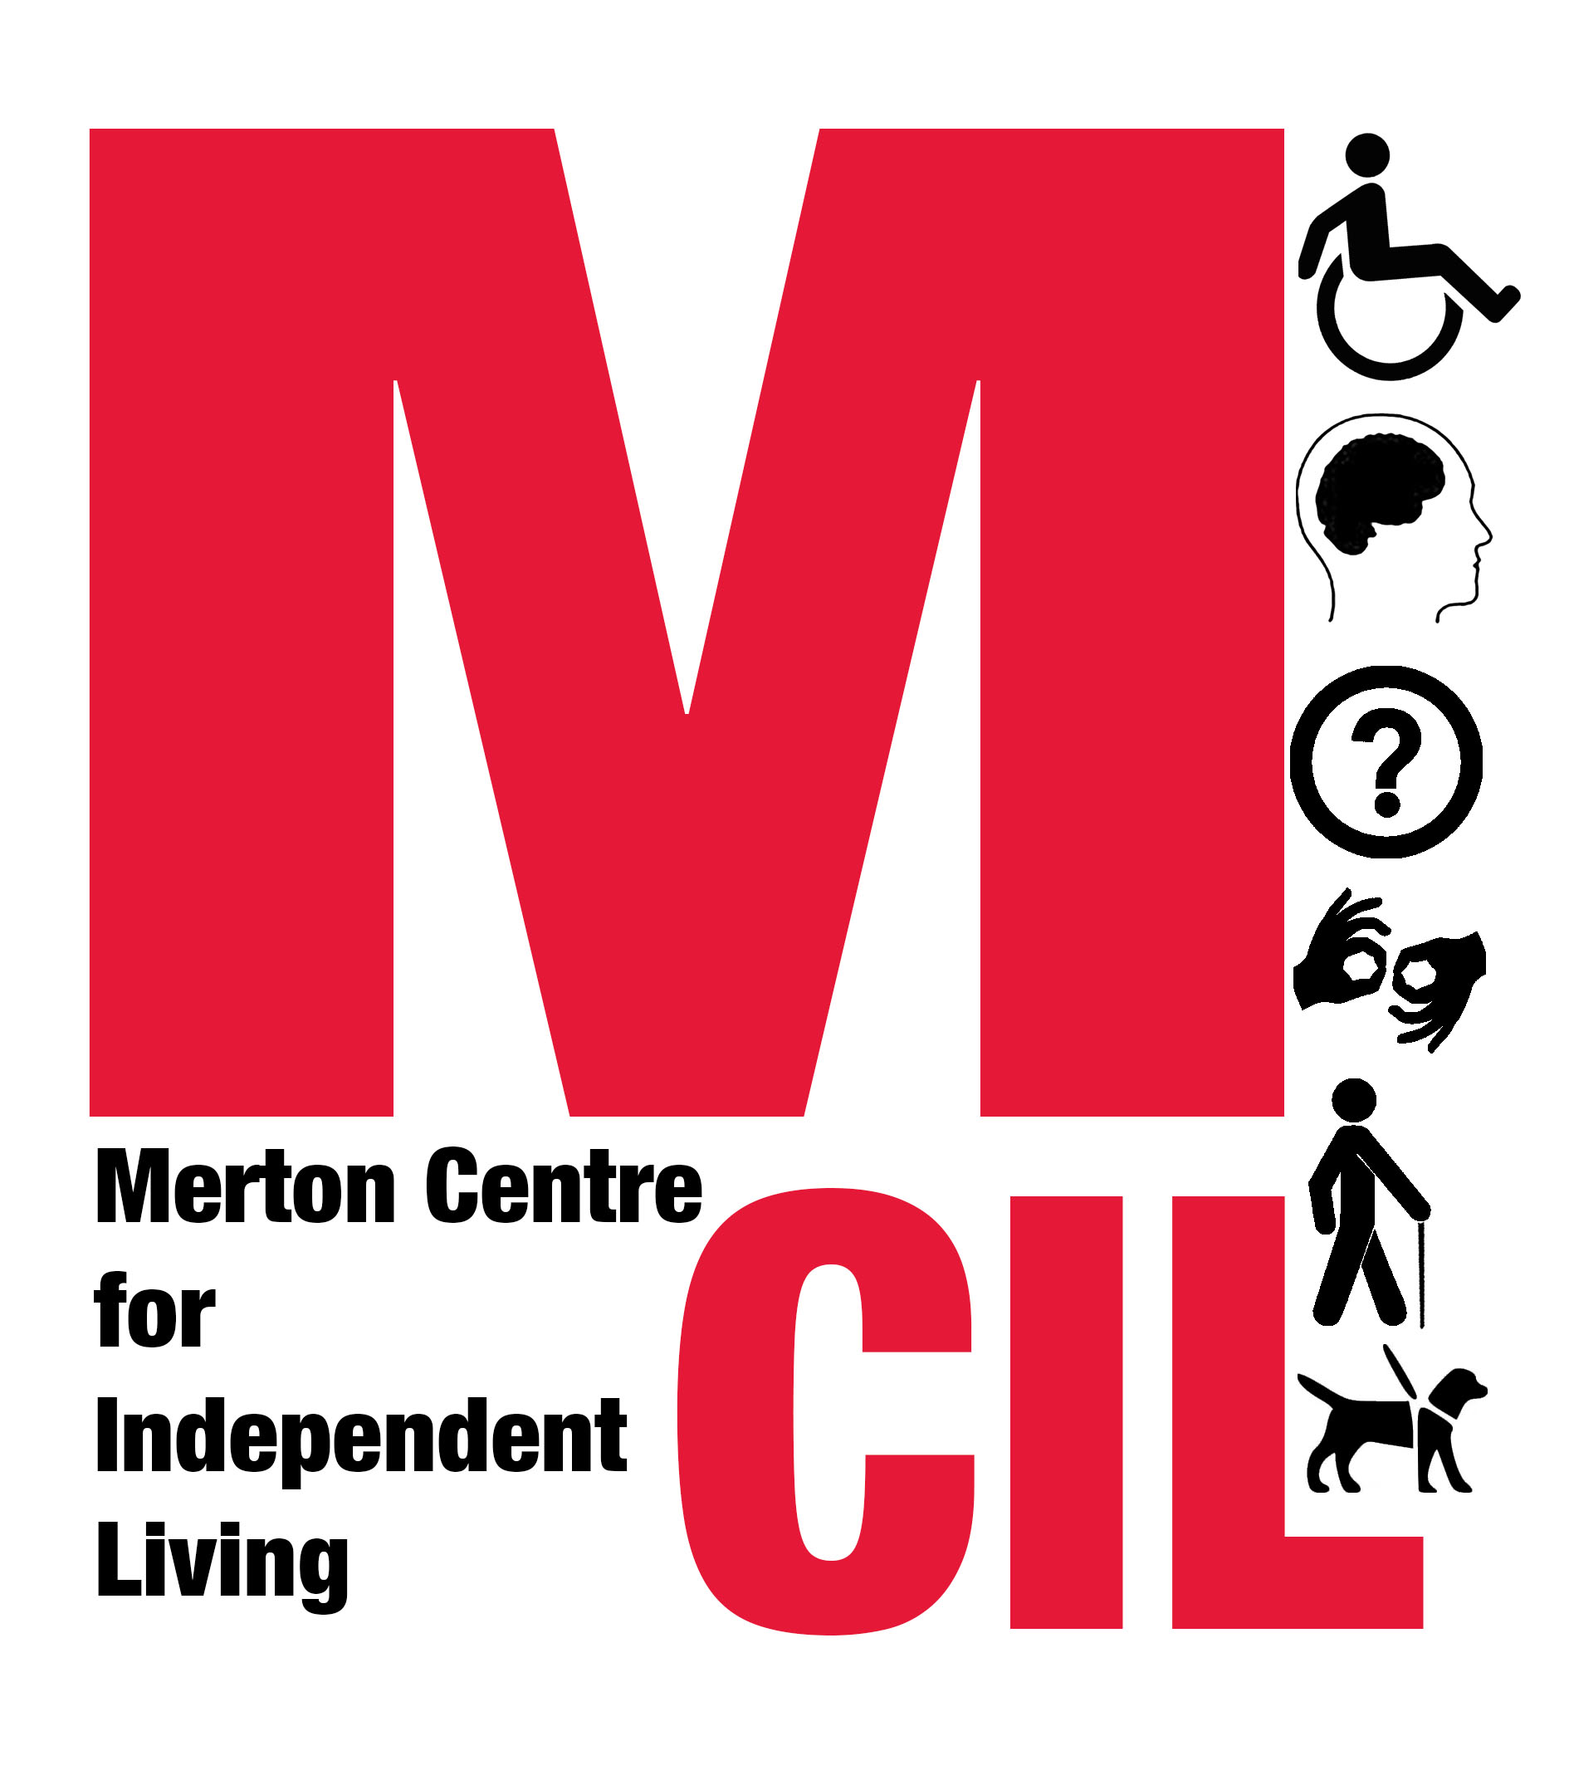
Job Description and Person Specification

Job title | Project & Evaluation Manager
Reporting to | Merton CIL CEO
Direct Reports | Supporting M&E volunteers
Hours | 21 hours per week
Salary | £30,000 - 35,000 pro-rata
Contract type | This is a funding-dependent fixed term contract for 2 years

Overall Purpose of Role

The post will manage all aspects of the evaluation for the Pan-London Hate Crime Partnership and selected projects within the Partnership, working collaboratively with Inclusion London’s London Hate Crime Partnership Project Manager. It will ensure that our partners meet all delivery and monitoring requirements, and that project communications, publicity and evaluation work is carried out to ensure learning from the project is captured and shared with stakeholders. The post will also undertake Merton CIL’s self-evaluation.
About Merton CIL

Merton CIL is a user-led organisation promoting the inclusion, choice, and independence of Disabled people in Merton. We were established to provide a voice for Disabled people and to provide support to Disabled people in all areas of their lives.

You can find out more about Merton CIL by watching this short film: https://www.youtube.com/watch?v=ecTQIfU4Doo

About the Pan-London Hate Crime Partnership

The Partnership is made up of 18 Deaf and Disabled People’s Organisations (DDPOs) working across London, and is building a pan-London collaborative DDPO response to hate crime and violence against Disabled people. Main partners in delivery of this project are Merton CIL, Stay Safe East and Inclusion London, as well as additional DDPOs per year.

Key Tasks and Responsibilities

Performance and contract management
- To coordinate effective delivery of outputs and outcomes by our DDPO partners, working collaboratively with our partners and our funder

- Co-ordination and management of quarterly quantitative and qualitative monitoring and evaluation returns from our DDPO partners and 6 monthly reporting to our funder

- To carry out regular contract review meetings with our DDPO delivery partners and contribute to quarterly partnership meetings

- To investigate any contract quality or compliance issues and work with DDPO delivery partners to manage service improvement activities in a proactive way

- To work with CEO and DDPO delivery partners to proactively identify other funding sources for further / additional work on this programme area/theme

Evaluation and Outcome measurement

- Development of an evaluation and outcome measurement framework which can be implemented across partners

- Supporting partners to develop appropriate outcome measurement tools within the overall framework, through meetings, desktop review, and development and delivery of guidelines

- Supporting partners to set up a self-evaluation steering group or similar model to lead on self-evaluation

- Coaching partners to implement and use outcome measurement tools

- To co-ordinate and lead the development of M&E resources, toolkits and events to disseminate learning from the project

- External evaluation of partner outcomes, working alongside partners in a collaborative way

Merton CIL’s Self-Evaluation Programme

- Support and lead Merton CIL’s Monitoring and Evaluation group

- Monitor progress against organisational objectives and outcomes, and prepare monthly monitoring reports on key indicators

- Prepare, analyse and report on key elements of evaluation framework and tools including feedback surveys, annual survey, staff survey, suggestion slips and review of compliments and complaints

- Take the lead on annual evaluation and business/strategic planning including focus groups and other means of hearing from service users and members

- Support with organisational quality assurance

- Support with individual project evaluations

- Take the lead on presenting the impact of our work through identifying and preparing key case studies and headlines.

General requirements

  - In conjunction with others, recruit, induct and train paid staff
  - Co-ordinate with the Senior Management Team to identify Social Policy issues and develop action plans
  - To support with planning and sustaining Merton CIL services, including contributing to business plans and funding bids
  - Manage and monitor any delegated budgets and follow Financial Procedures
  - To research and to keep informed of new legislation and changes to existing law and policy, trends and thinking on issues affecting Disabled People
  - To carry out the duties of the post within an equal opportunities framework and adhere to all Merton CILs policies and guidelines including our Values and Independence Charter
  - To undertake such duties as from time to time may reasonably be required.
  - This job description reflects the requirements of the post at the time of writing. The needs and circumstances may change over time and therefore the Job Description may need to be reviewed in the light of any such changes which may occur
  - To carry out additional tasks and attend out of hours and weekend events which may be required from time to time, under the direction of the CEO

Person Specification
Essential

- 3 years’ experience of successfully managing projects or services involving a range of partners / stakeholders

- At least 3 years experience of carrying out and meeting quantitative and qualitative monitoring and evaluation requirements including financial reporting and outcomes reporting

- Experience of developing effective relationships across different sectors and with diverse audiences

- Strong organisational skills including planning, problem solving, implementation support and high levels of attention to detail and accuracy
- Excellent communication, presentation and negotiation skills including the ability to write and present clear and accessible reports for a range of audiences
- Strong IT skills and ability to use electronic monitoring to keep records
- Highly motivated, with ability to work on own initiative, plan and prioritise own workload and work of others, meet tight deadlines and work flexibly as part of a small team
- Ability to handle with discretion information which may be confidential or sensitive
- A strong personal commitment to the Social Model of Disability and the Cultural Model of Deafness and a good understanding of the discrimination and exclusion faced by Deaf and Disabled people
- Willingness to travel within London and work occasional evenings
Desirable
- Lived experience of disability
- Experience of working in a user controlled and led organisation
- Experience of organising accessible services, events, meetings and/or training
Merton CIL is committed to equality, diversity and human rights. We particularly welcome applications from Deaf or Disabled people from all sectors of the community.
Please send a completed application form and monitoring form to:
info@mertoncil.org.uk

If you have any questions or access needs relating to your application, please contact us by email or by telephone on 020 3397 3119 (0744 936 2233 SMS)
Closing date for applications: 9am 25th March 2019
Planned interview date: 3 – 4 April 2019

This role is primarily funded by Trust for London

Merton CIL Charity Number 1152825. Company Number 7645926

