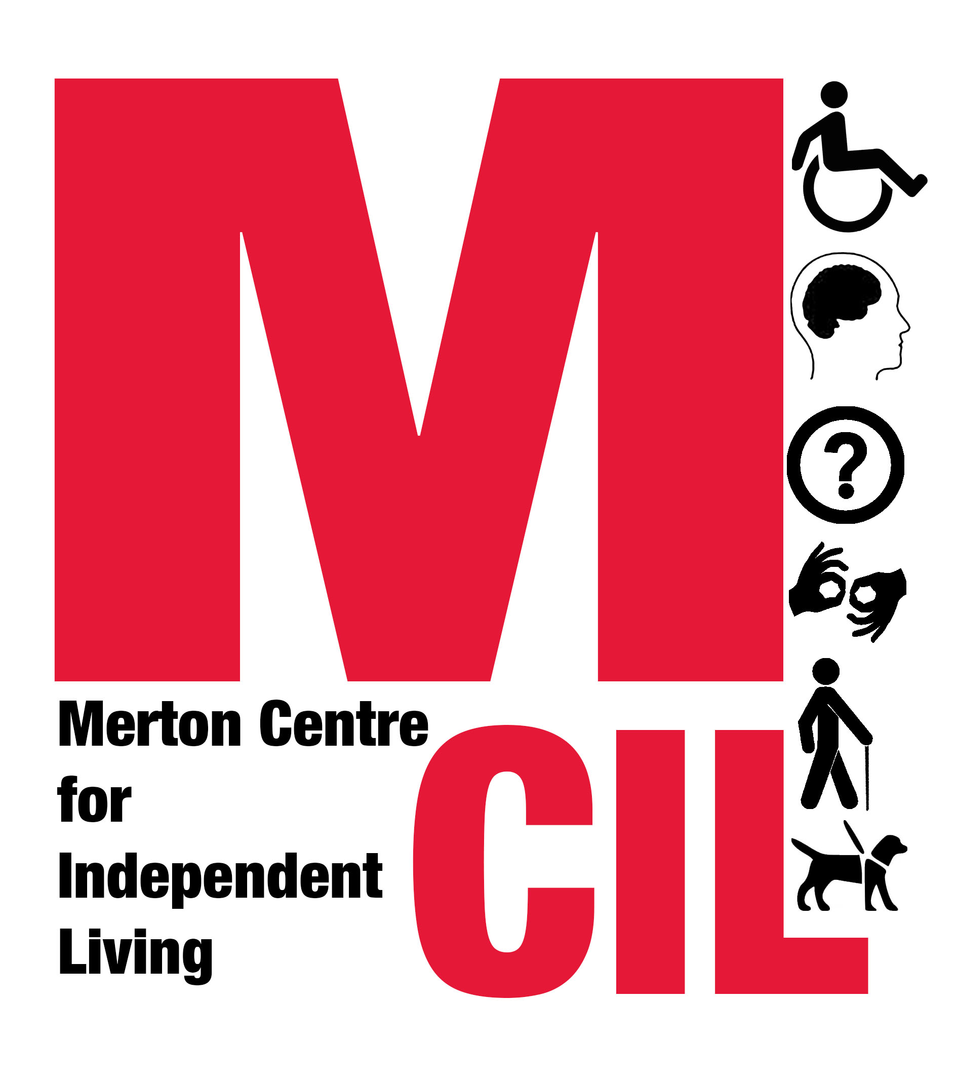
Job Description and Person Specification

Job title | Trainee Case Worker (Advice and Advocacy)
Reporting to  Hours | Service Manager  21-35 hours per week
Salary Starting salary circa £18,000 pro rata, with potential for increase to £24,000 pro-rata

Contract type Fixed term to 31/03/2020, with possibility of extension

Overall Purpose of Role
Working in line with our values as an organisation, to provide information, advice and advocacy support to Deaf and Disabled People in Merton in order to enable them to live independently and have as much choice and control over their lives as possible.

About Merton CIL
Merton CIL is a user-led organisation promoting the inclusion, choice, and independence of Deaf and Disabled People in Merton. We were established to provide a voice for Deaf and Disabled People in the borough and to provide support to Deaf and Disabled People in all areas of their lives.

You can find out more about Merton CIL by watching this short film: https://www.youtube.com/watch?v=ecTQIfU4Doo

About the Advice and Advocacy service
We provide advice in people’s own homes, and support people to speak up at a range of formal meetings such as assessments and welfare benefit tribunals. Our work is accredited by the Advice Quality Standard (AQS).

About the role
This is a great opportunity to develop core information, advice and advocacy knowledge and experience while working with and supporting our committed team of caseworkers.

For this role, we are specifically looking for someone to build up their skills and provide advice and casework in these key areas:

- Supporting local Deaf and Disabled people to successfully apply for Personal Independence Payment (PIP). This will include new PIP applications, PIP reassessments and Disability Living Allowance to PIP transfers and will cover form-filling, preparation for and support at health assessments, mandatory reconsiderations, appeal form filling (SSCS1s), drafting Tribunal submissions and support at First-tier Tribunals.
- Supporting local Deaf and Disabled people with their assessments for social care. This will include preparation for and attendance at needs assessments and reassessments, support with reviews, and advice on and support with financial assessments (including Disability Related Expenses) and charging.

We will support the post-holder through on-the-job coaching, development and supervision, and a range of employee benefits, and there may be opportunities for advice and/or casework in other areas of service delivery e.g. benefits other than PIP, money and budgeting.

We welcome applications from all sections of the community and the role would be equally as suitable for someone changing career as for someone just starting out.

Key Tasks and Responsibilities
- To support Deaf and Disabled people in Merton and to provide them with accurate advice, information and guidance in their own homes, enabling them to live more independently.
- To keep clear records of information, advice and advocacy support given and to enter key information on the database for monitoring purposes and for feeding back to funders and for quality checking.
- To support our team of caseworkers and to carry a caseload, providing support to Deaf and Disabled people on a person-centred basis in order to enable them to have as much choice and control over their lives as possible.
- To support Deaf and Disabled People with all aspects of the PIP application process, from form-filling to the First-tier Tribunal.
- To support Deaf and Disabled People with Care Act assessments, reassessments and reviews, including financial assessments.
- To provide advice and/or advocacy in other areas of service delivery as instructed by the Service Manager.
- To raise safeguarding concerns under the supervision of the Service Manager.
- Where appropriate, to refer people to other services in line with our policies and procedures, including other Merton CIL services.
- To research and to keep informed of new legislation and changes to existing law and policy on issues affecting Deaf and Disabled people.
- To prepare for, attend and contribute to support and supervision sessions.
- To prioritise and manage cases in line with quality standards.
- To carry out peer case reviews.
- To carry out the duties of the post within an equal opportunities framework and adhere to all Merton CIL’s policies and guidelines including our Values and Independence Charter.
- To undertake such duties as from time to time may reasonably be required.
- This job description reflects the requirements of the post at the time of writing. The needs and circumstances may change over time and therefore the Job Description may need to be reviewed in the light of any such changes which may occur.

Person Specification
Essential
- Willingness to learn and develop core advice and advocacy skills.
- Experience in being flexible and responsive to change.
- Experience working effectively as a member of a team.
- Ability to research, analyse and interpret complex rules and information.

Excellent written and oral communication skills, including the ability to explain and summarise complex rules and information in simple terms.
- Experience in enabling people to resolve their problems in a person-centred way.
- Experience planning and prioritising own work and meeting deadlines.
- Ability to handle with discretion information which may be confidential or sensitive.
- Strong IT skills (including Word, Excel, Outlook) and ability to use electronic monitoring to keep records of casework.
- Able to demonstrate an empathy for the issues and barriers faced by disabled people and an understanding of the policy issues affecting their lives.
- Must have a strong personal commitment to supporting people across the spectrum of disability or health issues, and supporting people from a variety of ethnic and social groups.

Desirable
- Experience of providing information, advice and/or advocacy support.
- Lived experience of disability.
- Experience of working in outreach locations and/or providing a home-visiting service.
- Experience of a user controlled and led organisation.
- An understanding of the Merton voluntary sector and local authority structures.
- An understanding and knowledge of the Social Model of Disability, the Independent Living Movement and a commitment to the disability rights movement.
We are an equal opportunities employer and we will interview and consider on their abilities Deaf and Disabled applicants who demonstrate that they meet the essential criteria for a job vacancy at Merton CIL, if they declare their disability at application.
If you require additional support completing this application due to an access need, please get in touch on 0203 397 3119.
Please apply with:
- A completed application form
- A completed personal details form
to info@mertoncil.org.uk
Deadline for receipt of applications: Wednesday 26 June at 5pm.
Interviews: Thursday 4 July at Merton CIL, Wandle Valley Resource Centre, Church Road, Mitcham CR4 3BE.
This role is funded by Trust for London’s Strengthening Voices Realising Rights programme.


