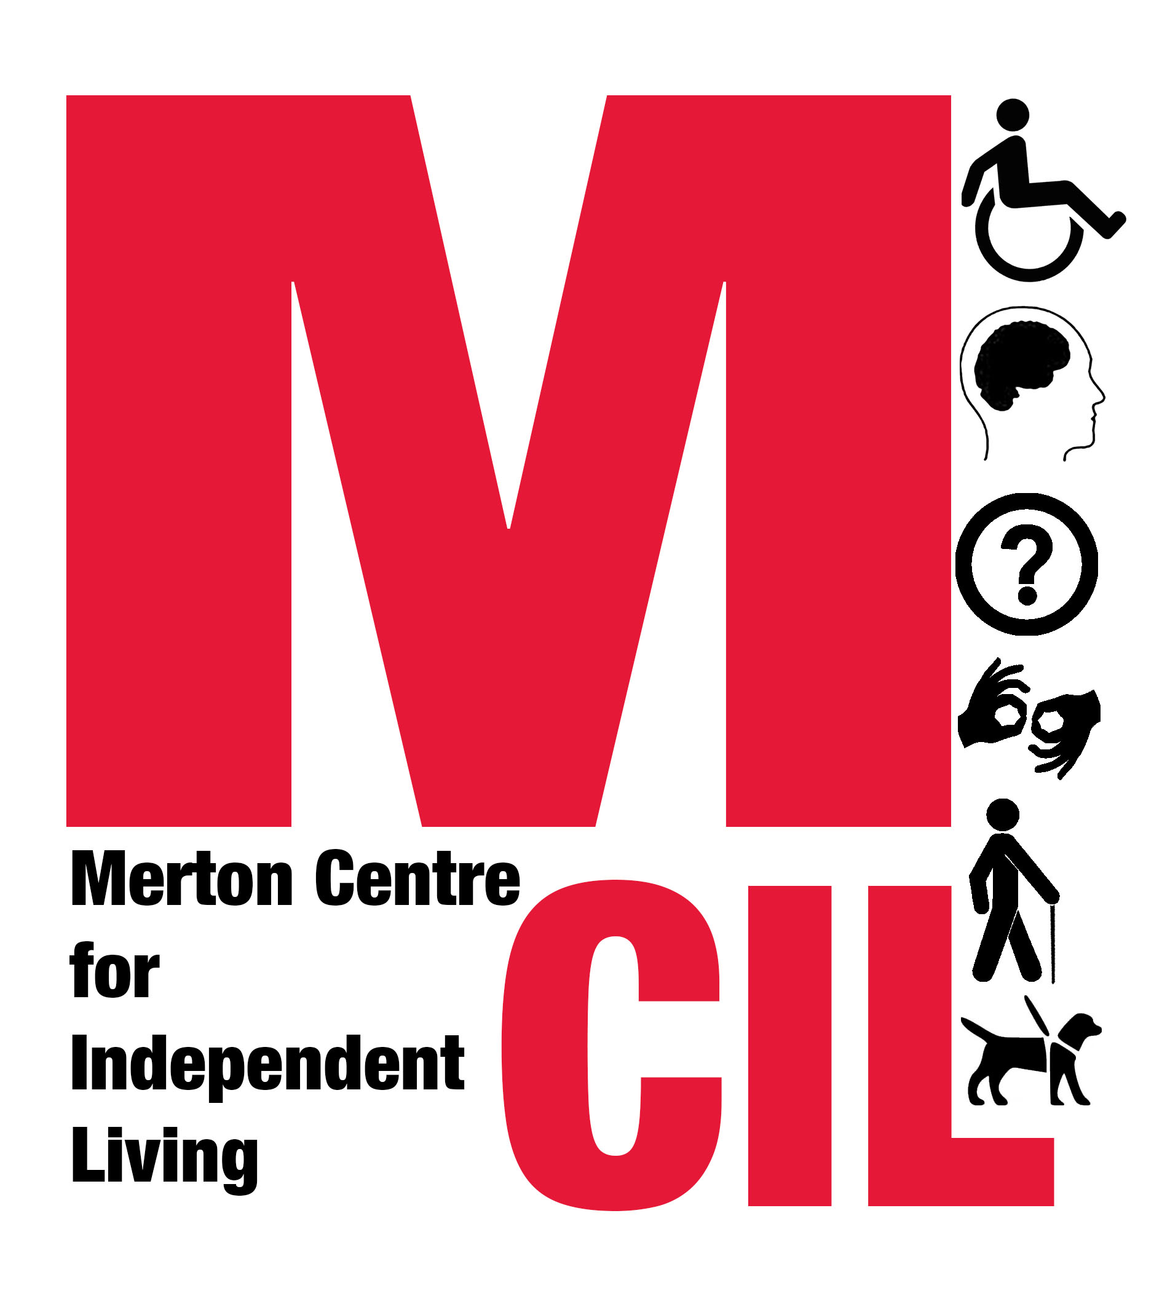
Job Description and Person Specification

Job title | Trainee Caseworker (Advice and Advocacy)
Reporting to  Hours | Service Manager  35 hours per week (job sharing will be considered)
Salary Starting salary £19,747.00 pro rata, with regular salary reviews

Start-date 01/04/2021 (or as soon as possible after this date)

Contract type Fixed term to 31/03/2022, with the possibility of extension, dependent on funding.

This post is open to Deaf or Disabled people only. This includes people who live with a long-term health condition.

This post is subject to a satisfactory Enhanced DBS (Disclosure and Barring Service) check.

Overall Purpose of Role
Working in line with our values as an organisation, to provide information, advice and advocacy support to Deaf and Disabled People in Merton in order to enable them to live independently and have as much choice and control over their lives as possible.

About Merton CIL
Merton CIL is a user-led organisation promoting the inclusion, choice, and independence of Deaf and Disabled People in Merton. We were established to provide a voice for Deaf and Disabled People in the borough and to provide support to Deaf and Disabled People in all areas of their lives.

About the Advice and Advocacy service
We provide advice, advocacy and casework support in Welfare Benefits and Community Care. Our work in these areas is accredited by the Advice Quality Standard (AQS).

We are funded to provide a home visiting service as well as office-based appointments. Since the first lock-down in March 2020, we have primarily been working from home, providing our service via telephone, email, letter and online platforms such as Zoom, WhatsApp and Skype. We did return to face-to-face appointments in October and November 2020 and we expect to be able to offer face-to-face appointments as 2021 progresses.

About the role
For this role, we are looking for someone to build up their skills and knowledge and to provide advice, advocacy and casework support in these key areas:

- Concessionary Travel applications, such as Disabled Persons Freedom Pass, Blue Badge, Taxicard, Dial-a-Ride.

- Community Care

You will be supporting local Deaf and Disabled people with their assessments for social care. This will include preparation for and attendance at needs assessments and reassessments, support with reviews, and advice on and support with financial assessments (including Disability Related Expenses) and charging.

- Personal Independence Payment

You will be supporting local Deaf and Disabled people to apply successfully for Personal Independence Payment (PIP). This will include new PIP applications, PIP reassessments and Disability Living Allowance to PIP transfers and will cover form-filling, preparation for and support at health assessments, mandatory reconsiderations, appeal form filling (SSCS1s), drafting Tribunal submissions and support at First-tier Tribunals.

We will support the post-holder through on-the-job coaching, development and supervision; internal and external training; and a range of employee benefits. There may also be opportunities for advice and/or casework in other areas of service delivery e.g. benefits other than PIP, budgeting, health.

The role is suitable for someone just starting out or someone looking to change career.

Key Tasks and Responsibilities
- To take part in all training and development activities as directed by the Service Manager, the Senior Caseworker and members of the Senior Management Team.
- To provide Deaf and Disabled people in Merton with accurate information and advice, enabling them to live more independently.
- To carry a caseload and to provide support to Deaf and Disabled people on a person-centred basis, enabling them to have as much choice and control over their lives as possible.
- To keep clear records of information, advice and advocacy support given and to enter key information on our database for monitoring purposes and for feeding back to funders and for quality checking.
- To support Deaf and Disabled People with Care Act assessments, reassessments and reviews, including financial assessments.
- To support Deaf and Disabled People with all aspects of the PIP application process, from form-filling to the First-tier Tribunal.
- To support Deaf and Disabled People with Concessionary Travel applications.
- To provide advice and/or advocacy in other areas of service delivery as instructed by the Service Manager.
- To answer the office telephone on a rota basis and take and record enquiries from service users, carers, members of the public and colleagues in the voluntary, statutory and private sectors.
- To work at all times within the Social Model of Disability.
- To raise safeguarding concerns under the supervision of the Service Manager.
- Where appropriate, to refer people to other services in line with our policies and procedures, including other Merton CIL services.
- To research and to keep informed of new legislation and changes to existing law and policy on issues affecting Deaf and Disabled people.
- To prepare for, attend and contribute to support and supervision sessions.
- To prioritise and manage cases in line with quality standards.
- To carry out peer case reviews when ready to do so and as advised by the Service Manager, Senior Caseworker or member of the Senior Management Team.
- To ensure appropriate public promotion of the service and to contribute to the design and updating of publicity materials for the service, as requested by the Service Manager, Senior Caseworker or member of the Senior Management Team.
- To keep up to date on what is offered by other agencies and promote collaborative working relationships with associated agencies within the Borough.
- To carry out the duties of the post within an equal opportunities framework and adhere to all Merton CIL’s policies and guidelines including our Values and Independence Charter.
- To undertake such duties as from time to time may reasonably be required.
- This Job Description reflects the requirements of the post at the time of writing. The needs and circumstances may change over time and therefore the Job Description may need to be reviewed in the light of any such changes which may occur.

Person Specification
Essential
- A Deaf or Disabled person or a person living with a long-term health condition.
- Self-motivated and keen to learn and develop new skills and knowledge.
- Capable of working supervised and unsupervised
- Excellent written and oral communication skills.
- Ability to be welcoming and compassionate.
- Ability to remain calm under pressure
- Ability to be flexible and responsive to change.
- Committed to fighting for justice.
- Committed to valuing people’s lived experience.
- Committed to working to the Social Model of Disability.
- Ability to work collaboratively as part of a team.
- Ability to maintain confidentiality.
- Strong IT skills (including Word, Excel, Outlook).
- Must have a strong personal commitment to supporting people across the spectrum of disability or health issues and to supporting people from a variety of ethnic and social groups.

Desirable
- Experience of providing information, advice and/or advocacy support, on a paid or a voluntary basis.
- An understanding of the Merton voluntary sector and local authority structures.

Closing date for applications: 11.00pm Thursday 18 February 2021.

Interviews will take place during the week commencing Monday 22 February 2021 via Zoom.

Candidates invited to interview will be informed by 5pm on Monday 22 February 2021.

Start date: 1 April 2021 or as soon as possible thereafter.

If you require additional support completing this application due to an access need, or if you would like further information about the role or the application process, please get in touch on 0203 397 3119.

Please apply with:
- A completed application form
- A completed personal details form
to manager@mertoncil.org.uk


This role is funded by Trust for London’s Strengthening Voices Realising Rights programme.

